An extraordinary year of

innovation, growth and impact

The choices we make at this pivotal moment for our company are key to

shaping our long-term vision – one that extends beyond strengthening

leadership positions in our core therapy areas to becoming a driving

force for improving human health worldwide.

As our business continues to grow, so does our role in society. The

global burden of serious chronic diseases casts a long shadow, and

demands innovative, disruptive solutions that are as sustainable as they

are impactful. Our core contribution to this fight remains our industry-

leading therapeutic innovations, which benefited more than 40 million

people living with serious chronic diseases in 2023. Yet we are also

increasingly focused on prevention as we seek to understand and

address the root causes of the diseases we treat.

The unmet needs in type 2 diabetes and obesity are growing by the

day, and the rising prevalence of these closely related threats to global

health has created surging demand for our GLP-1-based therapies. This

has enabled us to reach more patients than at any point in our 100-year

history, contributing to strong sales growth across North America and

International Operations. However, it has also increased pressure on

our supply chain, resulting in periodic constraints across our portfolio

as we strive to keep pace with demand.

We have responded by investing heavily in expanding our production

capacity with the aim of serving millions more patients worldwide. In 2023

alone, we announced investments totalling more than DKK 75 billion

It is a rare privilege for

any company to reach its

centenary; and even more

so to arrive at this milestone

in a position of strength.

As we reflect on 100 years

of driving change to defeat

serious chronic diseases, we

nevertheless acknowledge

that what got us here will

not be enough to take us

where we want to go.

President and CEO, Lars

Fruergaard Jørgensen (left)

and Chair of the Board of

Directors, Helge Lund (right).Novo Nordisk Annual Report 2023

Introducing Novo Nordisk Strategic Aspirations Risks Management Consolidated statements Additional information 4

in the expansion of our production sites across the globe. With

construction now underway on these projects, we strive to operate our

existing facilities 24 hours a day, seven days a week, as we produce

more of our life-changing medicines than ever before.

Our response to supply challenges does not stop there. We are also

changing the way we launch and distribute our products, making sure

we do this in a responsible manner with a clear focus on safeguarding

access to appropriate treatment options for our existing patients.

Recent examples of this refined approach include the launches of

Wegovy ® in the UK and Germany, where we are collaborating with

health authorities to ensure that some of those in greatest need of

medical intervention can access our flagship obesity therapy.

Improving health equity remains a cornerstone of our commitment to

patients, and we are working hard to enhance access to care worldwide.

Our new production partnership with manufacturer Aspen

Pharmaceuticals in South Africa will significantly increase the supply

of affordable insulin to the African continent, while long-established

initiatives, including Changing Diabetes ® in Children and our Access

to Insulin Commitment, continue to support vulnerable patients in

low- and middle-income countries. In the US, a growing number of

people living with serious chronic diseases have been able to access

our expanded range of affordability offerings, which include unbranded

biologics, low-cost human insulin and our Patient Assistance Program.

Despite these efforts, the burden of chronic diseases on healthcare

systems is only set to grow, pushing us to break new ground in our

pursuit of innovative treatments. To this end, we are building a pipeline

of considerable breadth and depth, powered by the interplay between

our world-class in-house R&D capabilities and an increasing focus on

external innovation and business development. Our distinct ownership

structure, with the Novo Nordisk Foundation retaining the majority vote,

gives us the security we need to take a long-term perspective on our

investments and strategies.

The past year has seen us make significant progress on our pipeline.

The SELECT trial showed that semaglutide 2.4 mg reduces the risk of

major adverse cardiovascular events by 20% in people with obesity

compared to placebo, prompting us to seek label updates for Wegovy ® ,

while the FLOW kidney outcomes trial for semaglutide closed early

following a positive analysis of interim data. Novel combination therapy

CagriSema entered phase 3 development in both type 2 diabetes and

obesity, and insulin icodec, potentially the world’s first once-weekly

basal insulin, is pending regulatory approval. We have also expanded

our footprint in cardiovascular disease with the acquisition of

ocedurenone for uncontrolled hypertension, and bolstered our

late-stage pipeline in rare blood disorders with phase 3 trials of Mim8

in haemophilia and etavopivat in sickle cell disease.

Furthermore, we continue to reap the rewards of recent partnerships

and investments in novel technology platforms, with our first-ever RNA

interference-derived therapy, Rivfloza™, now approved in the US. The

recent expansion of our R&D presence in the Greater Boston area – a

world-renowned life sciences cluster – will potentially open the door to

even more collaboration opportunities as we seek to accelerate our

drug discovery and development efforts.

Nevertheless, we understand that it will take more than medicine

to transition from a disease-focused company to one that prioritises

broader human health to the benefit of society at large. Leveraging

a decade’s worth of insights from our pioneering Cities Changing

Diabetes programme, we are enhancing our prevention efforts,

expanding our partnership with UNICEF to address childhood obesity,

and establishing a Transformational Prevention Unit to deliver scalable,

preventive solutions to the obesity pandemic.

Innovation plays an equally important role in our ambition to reach net

zero emissions across our entire value chain by 2045 – particularly with

our manufacturing output at an all-time high. Having already switched

our production sites to sourcing 100% renewable power, we are now

supporting a similar transition among our 60,000-plus network of

suppliers, with the aim of significantly cutting carbon emissions across

our supply chain.

The resilience and dedication of our growing global workforce

have been instrumental in scaling our operations in the face of

unprecedented demand. As we onboard more colleagues than ever

before, we are focusing on making Novo Nordisk a more diverse

and inclusive place to work, nurturing a culture built on openness,

accountability and respect. Above all, we remain a purpose-driven

company, guided by a clear ambition to drive change to defeat serious

chronic diseases, building on our heritage in diabetes. Our position

today in the vanguard of progressive global businesses is a testament

to the strength and longevity of that purpose – and to the drive and

motivation it provides for our people all over the world.

We would like to extend our gratitude to all colleagues for their

unwavering commitment and invaluable contributions during a

particularly demanding year, and to our shareholders for their

continued support of our company.

Helge Lund

#PARTTWO#

Driving change for a sustainable future

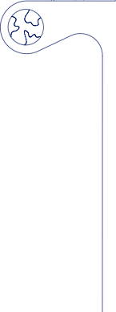

In a world facing urgent societal and environmental challenges, Novo Nordisk is playing a proactive role in the fight against health inequity and climate change. Guided by our purpose of driving change

to defeat serious chronic diseases and a steadfast commitment to social, environmental and financial responsibility, we are raising the bar to stay at the forefront of progressive global businesses.

Human health is under threat from a perfect storm of health inequity, climate change and biodiversity loss. As a leading healthcare company committed to serving patients across the globe, we have an important role to play in addressing these challenges. Our commitment to social responsibility and minimising our environmental impact are key to achieving our purpose and sustainability goals – and essential for our long-term success.

That is why we are striving to improve access to affordable care for vulnerable patients across the globe. More than three quarters of people with diabetes, for example, live in low- and middle-income countries, and that proportion is likely to grow as global prevalence rises from an estimated 537 million adults today to a predicted 643 million by 2030. Although we are now serving more people with diabetes than ever before, expanding our reach by more than four million patients to a total of 40.5 million last year, we recognise the need to do more.

Our key contribution to society remains our therapeutic innovation. However, we realise it will take more than medicine to defeat serious chronic diseases. This need is particularly acute in obesity, where medical intervention with treatments

like Wegovy® must be supplemented with prevention measures to head off a global pandemic that threatens to overwhelm healthcare systems. To this end, we have strengthened our focus on public-private partnerships and established a dedicated Transformational Prevention Unit tasked with delivering scalable commercial solutions that can help predict and pre-empt obesity.

We are also stepping up efforts to reduce our environmental impact by focusing on our supply chain emissions. Having already switched our production sites to sourcing 100% renewable power in 2020, we are now focused on supporting our 60,000-plus suppliers through a similar transition, with the aim of reaching net zero emissions across our full value chain by 2045.

To ensure that sustainability is integrated into Novo Nordisk’s core business, we have a series of governance measures in place that supplement the incorporation of environmental, social and financial responsibility in our Articles of Association. These include our Sustainability Advisory Council, established in 2022, which provides external input on our goals from experts in academia, public policy and patient advocacy, and an executive remuneration package directly linked to our progress on sustainability targets.

**STRATEGIC ASPIRATIONS 2025**

1. Progress towards zero environmental impact

2. Being respected for adding value to society

3. Being recognised as  
a sustainable employer

*For an overview of our purpose and sustainability initiatives, frameworks and performance, see the tables on pages 102-104.*

Novo Nordisk Annual Report 2023

Introducing Novo Nordisk **Strategic Aspirations** Risks Management Consolidated statements Additional information 12



Double materiality assessment

Novo Nordisk conducted an initial double materiality assessment in 2023 to determine which environmental, social and governance (ESG) topics are material for the company. This assessment considers both the impact of Novo Nordisk’s business on society and the environment (impact materiality) and how ESG matters affect the company (financial materiality). The assessment involved experts and leaders from within Novo Nordisk, as well as input from external stakeholders, such as patient organisations, suppliers and investors.

The purpose of the assessment is to prepare for the implementation of the Corporate Sustainability Reporting Directive (CSRD) in 2024. It covers all topics defined in the CSRD, along with other ESG topics relevant to Novo Nordisk. The table on the right shows the preliminary, aggregated results of the assessment, and includes both current and potential ESG topics from a short-, medium- and long-term perspective. The ESG topics will help guide the preparation of the company’s ESG reporting from 2024 onwards.

Many of the preliminary, material ESG topics reflect Novo Nordisk’s strategic sustainability focus. For social topics, this includes our efforts to provide access to life-saving medicines without compromising safety or quality, improve patients’ quality of life and support resilient healthcare systems. Workers’ wellbeing, both within and outside of our operations, reflects the importance of remaining a relevant and attractive workplace while respecting adequate working conditions. We also consider our local impact in the communities we operate in and pay tax where value is created.

The preliminary, material environmental topics reflect Novo Nordisk’s environmental initiatives to reduce carbon emissions and promote a circular economy, for example on plastic. ESG topics such as biodiversity and water reflect the company’s dependence on nature-based resources. To this end, Novo Nordisk is already increasing sustainability efforts directly related to nature and biodiversity. Moreover, the company strives to limit any negative effects resulting from its business operations, including pollution.

Business conduct reflects our efforts to adhere to the highest ethical standards, including bioethics. Overall, Novo Nordisk aims to be respected for its contributions to society and to build trust through its sustainability efforts.

**Preliminary assessment of material ESG topics**



Climate change

Resource use and circular economy

Water and marine resources

Biodiversity and ecosystems

Pollution

Patient protection1 and quality of life

Own workers

Workers in the value chain

Sustainable tax

Affected communities

Business conduct

Bioethics



1. Includes topics related to consumers and end-users.

Novo Nordisk Annual Report 2023 Introducing Novo Nordisk **Strategic Aspirations** Risks Management Consolidated statements Additional information 13



Cutting emissions in collaboration with our suppliers

According to the World Health Organization, climate change is the single biggest health threat facing humanity. We recognise that caring for our patients also means caring for our planet, and with the healthcare sector as a whole accounting for approximately 5% of global emissions, we take our environmental impact seriously. We are determined to play our part in creating a sustainable, healthy environment for the long term, and our ambition is bold and simple: to have zero environmental impact.

To achieve this, one of our key tasks is to decouple the growth in our business from our CO2 equivalent (CO2e) emissions; otherwise, our carbon footprint will continue to climb as we serve increasing numbers of patients.

*“Focusing solely on our own activities is not enough. We must also ensure our 60,000-plus suppliers play their part in this transformation.”*

On this front, we have made significant progress in curbing our company’s emissions. Since 2020, all our production sites have sourced 100% renewable power and we aim to reach zero CO2e emissions from operations and transportation by 2030.

However, focusing solely on our own activities is not enough. We must also ensure our 60,000-plus suppliers play their part in this transformation, since their activities account for the majority of our total CO2e emissions – amounting to 98% in 2023. Our target is that all goods and services from suppliers will be based on 100% sourced renewable power by 2030.

We are engaging with suppliers in high-impact areas to understand how we can collectively reduce emissions using novel approaches to decarbonisation. This involves working on innovative Power-to-X solutions that use renewable electricity to produce green fuels and low-carbon chemicals, or using organic waste materials to produce biofuels.

Recent examples include our membership of the Sustainable Aviation Buyers Alliance (SABA) to support the expansion of sustainable aviation fuel facilities, and our partnership with global logistics firm Maersk on low-emission fuels for ocean freight. Both these investments are contributing to the global uptake of innovative green technologies.

15 (1,000 tonnes CO2e) 78

**SCOPE 1, 2 AND 3 EMISSIONS IN 2023**

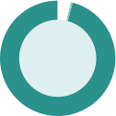

Scope 1:  
Direct emissions from owned or controlled sources

Scope 2:  
Indirect emissions from the generation of energy purchased from an utility provider

Scope 3:  
All indirect emissions – not included in scope 2 – that occur upstream and downstream in our value chain

*Target 2045: net zero CO2e emissions across our full value chain*

3,738

**EMISSIONS FROM OPERATIONS AND TRANSPORTATION**(1,000 tonnes CO2)1

Company cars (scope 1)

Business flights (scope 3)

Product distribution (scope 3)

Office buildings and laboratories (scope 1, 2)

Production (scope 1, 2)

*Target 2030: zero CO2e emissions from operations and transportation*

309

170 174

2020 2021

221

**203**



1. Emissions in 2023 are measured in CO2e.

2019

2022 **2023**

Novo Nordisk Annual Report 2023

Introducing Novo Nordisk

**Strategic Aspirations** Risks Management Consolidated statements

Additional information 14



Reducing our plastic footprint

Minimising the use of plastic derived from fossil fuels is a priority for Novo Nordisk – and a significant challenge given the rapid growth in demand for our medical injection devices. We currently manufacture more than 800 million pre-filled plastic pens every year, equivalent to some 14,000 tonnes of plastic. As the number of patients we serve continues to grow, those numbers will rise markedly unless we take decisive action.

We are tackling our plastic challenge on multiple fronts, with a threefold ‘reduce-change-avoid’ approach. This includes reducing plastic consumption by converting to reusable devices, changing to the use of non-virgin-fossil plastics in our device production and harnessing recycling to avoid plastic ending up in landfill.

*“In 2023 we established the world’s first industry solution for recycling injection pens in Denmark.”*

The task is not simple. When it comes to recycling, for example, used injection pens cannot be dealt with in the same way as other household recycling because they are classified as medical waste, which most countries are not equipped to handle. To address this challenge, we have expanded a series

of pioneering take-back programmes across Denmark, the UK, France and Brazil, and in 2023 we established the world’s first industry solution for recycling injection pens in Denmark. Pharmaceutical companies Lilly, Sanofi and Merck have all joined the initiative, and we now share a goal of recycling 25% of the pens distributed by all four companies in Denmark within the first 12 months.

Another important initiative involves rethinking medicine delivery by switching from disposable to reusable devices –

some with an expected lifespan of up to 5 years. Over the year, we have converted selected products in a number of countries and we expect to switch more in 2024. We are also steadily building device durability into the development of new medicines and expect that a trend from daily to once-weekly administration for many products will contribute to reduced plastic use per patient in the long term.

In addition, we are exploring more sustainable ways to produce plastic. A good example is a new agreement signed by Novo Nordisk, alongside the LEGO Group, to buy e-methanol from European Energy when the world’s first large-scale production plant for the commodity starts up in Denmark in 2024. The e-methanol – made from renewable electricity, water and captured biogenic CO2 – will help us to create lower-carbon plastics for use in our medical devices.

past

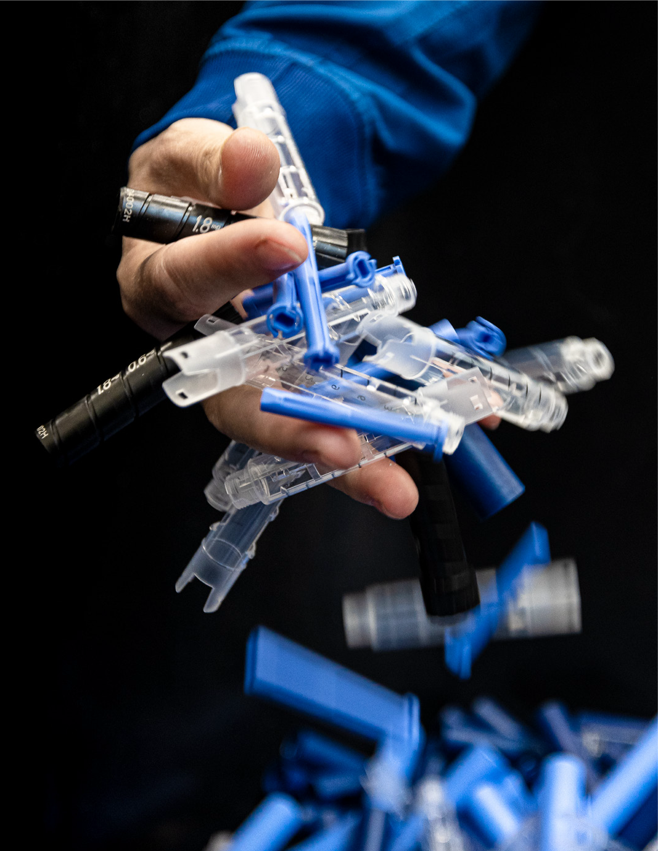

Injection pens’ components that have been discarded from our production lines in Hillerød, Denmark.

Novo Nordisk Annual Report 2023

Introducing Novo Nordisk **Strategic Aspirations** Risks Management Consolidated statements Additional information 15

Supporting more people with diabetes

With the number of adults living with diabetes across the globe predicted to grow from 537 million today to 643 million by 2030, it is those in the most vulnerable settings who struggle the most to access the treatment they need. Last year, we reached more than 40.5 million people with our diabetes medicines – an increase of 4.2 million on 2022 – but we recognise the need to do more. For that reason, we are committed to improving affordability for vulnerable populations, increasing availability by strengthening supply chains and expanding the capacity to diagnose and manage diabetes worldwide.

Over the past year, we reached 6.7 million people living with diabetes globally with our insulin medicines through access and affordability initiatives, and we extended support to more than 52,000 children with type 1 diabetes through our Changing Diabetes® in Children programme. In the US, we provided access to affordable insulin for 1.4 million people and supported a further 2.8 million with initiatives relating to our GLP-1-based therapies.

On the African continent, we doubled down on our commitment to improve access to insulin, establishing a new partnership with South African pharmaceutical manufacturer Aspen Pharmaceuticals to increase production for distribution across the region. The partnership acknowledges the World Health Organization’s call for sustainable access to quality-assured and affordable medicine through local manufacture and aims to produce more than 60 million vials by 2026. This is equivalent to the annual requirements

of around four million people – a significant increase on the 500,000 we currently serve. Sub-Saharan Africa is currently home to an estimated 24 million adults living with diabetes.

The human insulin produced by the collaboration will be distributed at low-cost as part of Novo Nordisk’s Access to Insulin commitment, which reached 2.4 million people in 2023. The programme guarantees a ceiling price of USD 3 per vial in 77 low- and middle-income countries around the world.

However, increasing the availability of insulin alone is not enough. To enhance access to equitable care in Sub-Saharan Africa, we have built a business integrated model – iCARE – which is now active in 49 countries. Through public-private partnerships we aim to improve capacity to treat diabetes, increase affordability

of insulin and enhance patient empowerment. Our ambition is to reach more than two million vulnerable people living with diabetes in Sub-Saharan Africa by 2030.

**PEOPLE REACHED WITH OUR DIABETES MEDICINES** (million)

40.5 2020 2022 2023

30.0 34.6 2019 2021

32.8 36.3

Dr. Karaireho Silver Bahendeka is a physician for diabetes and endocrinology at St Francis Nsambya Hospital in Kampala, Uganda.

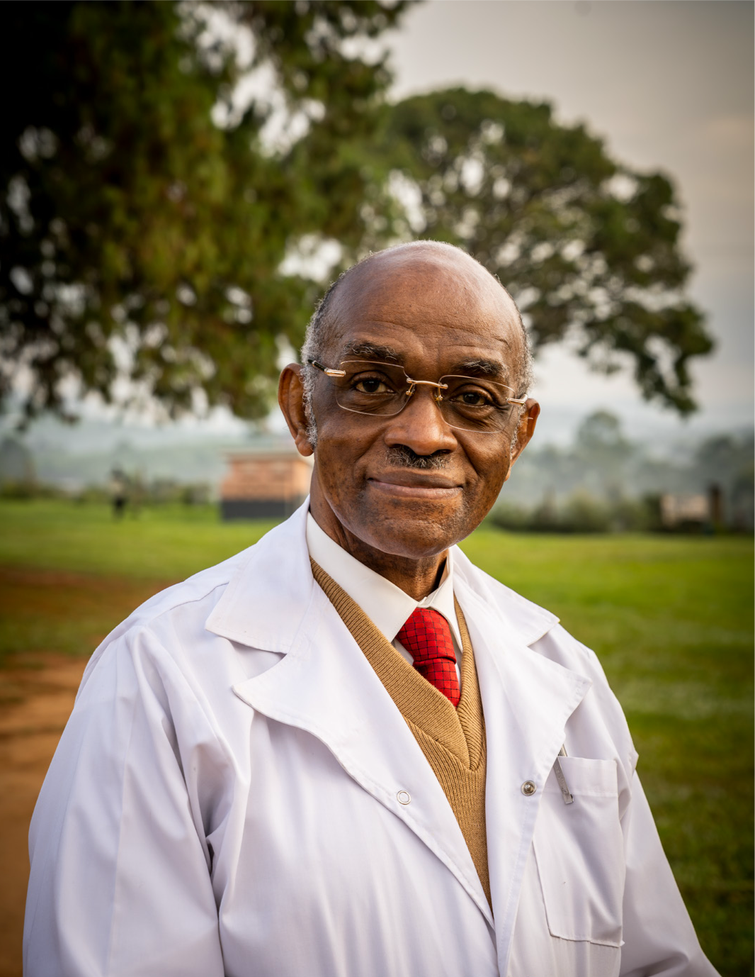

Novo Nordisk Annual Report 2023

Introducing Novo Nordisk

**Strategic Aspirations** Risks Management Consolidated statements

Additional information 16

Preventing obesity, starting with children

The obesity epidemic is one of the greatest threats to global health, currently impacting more than 813 million adults worldwide and responsible for five million deaths each year. In addition, obesity impacts the sustainability of health systems and economic productivity. While Novo Nordisk’s core contribution to the fight remains our therapeutic innovations, which reached more than 1.1 million people worldwide in 2023, we recognise that medicine alone will never be enough to defeat obesity. We are therefore committed to addressing the disease holistically by scaling up our focus on prevention

– and nowhere is this more urgent than in childhood.

More than 310 million children and adolescents are expected to be living with obesity by 2030, with those in vulnerable settings more at risk. These individuals are more likely to develop early- onset type 2 diabetes, and their weight in early life can also be a strong predictor of adult obesity and cardiometabolic disease.

We believe that preventing childhood obesity is a shared societal responsibility that requires systemic change. Many  
of the risk factors driving the epidemic are outside of an individual’s control, reflecting rapid urbanisation and the health challenges that come in its wake, from physical inactivity to the prevalence of foods high in fats, sugar and salt.

Our childhood obesity partnership with UNICEF – which was expanded in 2023 and aims to reach 10 million children across

the globe – zeroes in on exactly these key issues through policies, programmes and practices that directly impact the nutrition, wellbeing and development of children.

Since its launch in 2019, the partnership has positively impacted the lives of more than 2.7 million children and caregivers across Latin America and the Caribbean. Now it is expanding its reach, bringing its proven approach to new geographies with an increased focus on driving policy change at national level and action at city level.

Through local engagement and cross-sector collaboration, we are focusing on interventions with demonstrable track records. These include advocating for healthy school food regulations in Brazil, addressing unhealthy food marketing directed at children online in Mexico and trialling innovative measures to improve urban food retail environments in Indonesia.

The partnership will draw upon insights from our Cities Changing Diabetes programme, now active in 47 cities globally, which over the past decade has addressed the systemic issues underpinning the rise in type 2 diabetes and obesity in urban environments. Our broader obesity prevention efforts will be boosted by our recently-established Transformational Prevention Unit, a semi-autonomous team of multi-disciplinary experts tasked with delivering high-impact, scalable and accessible solutions that can predict and pre-empt obesity and its consequences.



Girls playing in the Mexican state of Chiapas. Mexico was among the launch countries for our partnership with UNICEF, and Mexico City was the first metropolis to join Cities Changing Diabetes. Photo: UNICEF.

Novo Nordisk Annual Report 2023 Introducing Novo Nordisk **Strategic Aspirations** Risks Management Consolidated statements Additional information 17

Empowering colleagues through diversity and inclusion

Diversity and inclusion are central to our business and purpose. In our rapidly growing organisation, we aim to create an inclusive culture where all employees feel valued and are given equal opportunities to realise their potential and where, together, we better reflect the diversity of the patients and communities we serve. Encouraging diverse perspectives and promoting inclusive leadership adds value to Novo Nordisk by bringing out the best in our people, fostering new ideas and sparking innovation.

Our aim is to achieve balanced gender representation across all managerial levels, with a minimum of 45% women and 45% men in senior leadership roles by the end of 2025. There is still work to be done but we are making significant progress. At the end of 2023, 41% of senior leadership positions were filled by women, compared to 39% one year earlier.

Gender is only one element of diversity, and we want to build a more representative workforce across all dimensions, including ethnicity, race, age, nationality, disability status  
and sexual orientation – not to mention diversity of thought. We are committed to including these important parameters globally as we embed them into our people processes and the employee experience, from initial attraction and recruitment through to talent development and leadership training.

In the context of the rapid growth of our global organisation, this is no small feat. We added more than nine thousand employees to Novo Nordisk in 2023, and have gone to great lengths to sharpen our focus on onboarding and upskilling our new colleagues into their new roles, nurturing a workplace culture built upon foundational values of openness, accountability and respect. We measure our success in this regard by tracking employee engagement via a yearly all-company Evolve survey, recording an overall engagement score of 86% in 2023 – up from 85% in 2022 and placing us in the top quartile of Most Engaged Companies for the first time.

**WOMEN IN LEADERSHIP** (%) EVP/SVP

CVP VP

Senior leadership

Director  
Manager and team lead **All leaders**

2019 2020 18 24 33 37 35 36

33 35

43 41 40 42 40 41

2021 2022 **2023** 28 29  
39 40  
36 40

36 39

44 44 43 45 43 44

|  |
| --- |
| 36 |
| 41 |
| 42 |
| 41 |
| 47 |
| 46 |
| **46** |



Michele De Gier Gustafsson heads a clinical digital systems team in Søborg, Denmark.

Novo Nordisk Annual Report 2023

Introducing Novo Nordisk **Strategic Aspirations** Risks Management Consolidated statements Additional information 18

Statutory gender reporting under Danish law

Listed companies not having equal representation of genders on the Board of Directors are required to set a target for the share of the underrepresented gender. As of 1 January 2023, listed companies are also required to set a target and a policy for the share of the underrepresented gender in upper management1.

inclusion brings value to the company, by enabling a diverse line of thought, increasing innovation and leading to better decision-making.

The policy focuses on three primary drivers: mitigating bias, creating an inclusive workplace and having leaders serve as role models. Its most significant activities include yearly equal pay reviews, a global gender- neutral parental leave policy, tracking of gender representation across all managerial levels and aspirational gender diversity targets.

Further reporting on diversity and inclusion is included in note 8.3 on Gender diversity, and for the Board of Directors, also in the Corporate Governance Report. Novo Nordisk’s diversity and inclusion policy is available at: www.novonordisk.com/sustainable-business/esg-portal/ principles-positions-and-policies/diversity-inclusion-policy.html.

Sustainable tax approach

Our overall guiding principle within taxation is to have a sustainable tax approach, emphasising our business-anchored approach to managing  
the impact of taxes while remaining true to the Novo Nordisk values of operating our business in a responsible and transparent manner. Our legal structures are based on business-anchored considerations and substance.

Consequently, we pay tax where value is generated and always respect international and domestic tax rules. As a global business, we conduct cross-border trading, which is subject to transfer pricing regulations. We apply a ‘Principal structure’ in line with OECD principles, meaning all legal entities, except for the principals, perform their functions under contract on behalf of the principals. As a result, entities contracted by the principals are being allocated an activity-based profit according to a benchmarked profit margin. The tax outcome of this operational model is reflected in the overview to the right, which shows our corporate income taxes by region.

To ensure alignment between tax authorities regarding the allocation of profit between our entities, we aim to have Advance Pricing Agreements and similar tax rulings in place for geographies representing around 70% of our revenue worldwide.

Our tax policy has been approved by the Board of Directors. Read more about this at: www.novonordisk.com/sustainable-business/esg-portal/ principles-positions-and-policies/tax-policy.html.

In addition to corporate income taxes, we also pay other taxes. Please refer to note 8.7 on Total tax contribution for further information.

**SHARE OF THE UNDERREPRESENTED GENDER (2023)2**

**TAXES BY REGION (THREE-YEAR AVERAGE 2021-2023)**

**Share of the underrepresented gender**

2022 **2023** 33% (3/9)

38% (19/50)

**Target for the share of the underrepresented gender**

Not required Min. 45% by 2025

Region

**International Operations**

Intellectual property rights6

Production7 Sales8

Corporate income taxes (DKK billion)

**14.2**

Total tax contribution (DKK billion)

**32.8**

21.6 5.4 2.6 3.2 **7.1** 7.0

**39.9**



|  |
| --- |
| 38% (3/8) |
| 42% (19/45) |

Board of Directors3 Upper management4

Denmark 12.2

As of 31 December 2023, the Board of Directors is regarded as having equal gender representation and is therefore not legally required to set a gender target5. Since diversity remains important for the Board, it has maintained a voluntary 2025 target of having at least three shareholder- elected Board members who are men and three who are women.

As of 31 December 2023, the share of the underrepresented gender in upper management at Novo Nordisk A/S is 42%. Accordingly, we have achieved equal gender representation as defined under the Danish companies act. However, we have not yet achieved the targeted level of 45% and therefore maintain our diversity and inclusion policy to keep making progress. This policy states our strong belief that diversity and

EMEA (excluding Denmark) China  
Rest of the world  
**North America Operations** US

**Total three-year average**

Minor or no activities

Share of category

1.0 0.6 0.4 **1.1** 1.0

**15.3**

Significant activities



1. Cf. the Danish Companies Act, section 139 (c). 2. Cf. the Danish Financial Statements Act. section 99(b). 3. Shareholder-elected Board members of Novo Nordisk A/S. 4. Chief executive officer and executive vice presidents employed by Novo Nordisk A/S as well as their direct reports, also employed by Novo Nordisk A/S, with leadership responsibility. 5. Cf. the Danish Companies Act, section 139(c)(1)(1). 6. Intellectual property rights based on sales from where intellectual property rights are located. 7. Production based on number of production employees in the region. 8. Sales based on location of the customer.

Novo Nordisk Annual Report 2023

Introducing Novo Nordisk **Strategic Aspirations** Risks Management Consolidated statements Additional information 19



Setting high standards for how we do business

Our business has come under increasing scrutiny over the past year – particularly with regard to our GLP-1-based products – as the level of public interest in our company has grown significantly.

Against this backdrop, we have remained steadfast in our commitment to uphold high ethical standards and adhere to the regulatory requirements of different authorities. In the face of unprecedented demand for our medicines – particularly our GLP-1-based therapies – we have also strengthened our focus on ensuring that only the approved indications of our products are promoted.

At times, however, we were challenged in our aspirations. In the UK, for example, we received a two-year suspension from The Association of the British Pharmaceutical Industry (ABPI) in 2023 after the trade body found Novo Nordisk to be in breach of the industry’s self-regulatory code of practice. The breach related

to the provision of insufficient information regarding our sponsorship of a weight management course offered by a third-party clinical training provider for healthcare professionals.

When mistakes are made, we learn from them. Over the past year, we invested substantial resources in robust training for colleagues with the aim of ensuring we always deliver the right message, whether we are addressing the general public

or healthcare professionals. We have also strengthened our governance processes in key affiliates via local ethics and

compliance committees, and we are ready to step up our monitoring efforts by significantly increasing the number of internal checks and reviews in 2024.

More broadly, our new global code of conduct sets out the fundamental principles and required behaviours for our employees and collaborators and is rooted firmly in the Novo Nordisk Way Essentials – a foundational set of guiding principles that shape and inform everything we do. We use a unique, systematic approach known as facilitation to ensure everyone lives up to these Essentials. In 2023, 42 units and approximately 2,300 employees were facilitated, compared to 36 units and 1,700 employees in 2022. Any issues are addressed locally, and a consolidated report is shared with the Board of Directors and Executive Management.

We also measure the extent to which we live up to societies’ expectations through several other governing processes. These include our company reputation score among key stakeholders (see pages 41-42 for more information), regular product quality and supplier audits, and an enduring commitment to ensuring the accuracy of our financial and ESG reporting via both internal and external audit processes. Our financial reporting and associated processes are audited according to the Sarbanes-Oxley Act by an independent audit firm elected at the Annual General Meeting, and we voluntarily include an Assurance Report from an independent external auditor for ESG reporting in the Annual Report.

**The Novo Nordisk Way Essentials**

We create value by having a patient-centred business approach.

We set ambitious goals and are empowered to achieve them.

We are accountable for our financial, environmental and social performance.

We are curious and innovate for the benefit of patients and society at large.

We build and maintain good relations with our stakeholders.

We have a healthy and engaging working environment.

**1**

**2**

**3**

**4**

**5**

We value diversity and treat everyone with respect.

**6  
7** We focus on performance and personal development.

**8**

We strive for agility and simplicity in everything we do.

**9  
10** We never compromise on quality and ethics.

Novo Nordisk Annual Report 2023

Introducing Novo Nordisk **Strategic Aspirations** Risks Management

Consolidated statements Additional information 20



Corporate Governance

**Governance structure**

The shareholders of Novo Nordisk exercise their rights at the Annual General Meeting, which is the supreme governing body of the company. The general meeting inter alia adopts the company’s Articles of Association, approves the Annual Report and elects the Board of Directors.

Any shareholder has the right to raise questions at general meetings. Resolutions can generally be passed by a simple majority. However, resolutions to amend the Articles of Association require two-thirds of the votes cast and capital represented, unless other adoption requirements are imposed by the Danish Companies Act.

Novo Nordisk has a two-tier management structure consisting of the Board of Directors and Executive Management. The governance structure and rules of Novo Nordisk are further described in our Articles of Association and our Corporate Governance Report, both available at: www.novonordisk.com.

**Foundation ownership**

Novo Holdings A/S, a Danish company wholly owned by the Novo Nordisk Foundation, holds the majority of votes at Novo Nordisk A/S’ general meetings. The combination of foundation ownership and stock listing enables Novo Nordisk to embark on long-term sustainable strategies while maintaining short-term transparency on performance. Our foundation ownership supports the overarching imperative to be both commercially successful and responsive to the wider needs of society.

The objectives of the Novo Nordisk Foundation are to provide a stable basis for the commercial and research activities of Novo Nordisk and Novozymes, and to support scientific, humanitarian and social causes. Please refer to the section about value creation on page 7. For more information about the ownership structure of Novo Nordisk, see page 38.

**Corporate Governance reporting**

Novo Nordisk reports in accordance with the Danish Corporate Governance Recommendations designated by Nasdaq Copenhagen as well as the Corporate Governance Standards of the New York Stock Exchange applicable to foreign private issuers.

In 2023, Novo Nordisk complied with the Danish Corporate Governance Recommendations as we either complied with or explained our approach to the recommendations. You can find further information about our corporate governance practices in our 2023 Corporate Governance Report, in accordance with section 107b of the Danish Financial Statements Act, available at: www.novonordisk.com/about/corporate-governance.html.

**Remuneration**

Executive remuneration is linked to performance on financials as well as non-financials (e.g. innovation, sustainability). Novo Nordisk has prepared a separate Remuneration Report describing the remuneration awarded or due during 2023 to the Board of Directors and Executives registered with the Danish Business Authority. The Remuneration Report is submitted to the Annual General Meeting for an advisory vote. The Remuneration Policy and the Remuneration Report are available at: www.novonordisk.com/about/corporate-governance.html.

**Disclosure regarding change of control provisions**

The EU Takeover Bids Directive1, as partially implemented by the Danish Financial Statements Act, requires listed companies to disclose information that may be of interest to the market and potential take-over bidders, in particular in relation to disclosure of change-of- control provisions in material contracts.

It is disclosed that Novo Nordisk does not have any material contracts that take effect, alter or terminate upon a change of control of Novo Nordisk following implementation of a takeover bid. In relation to the registered management of Novo Nordisk A/S, the current employment contracts allow for severance payments of up to 24 months’ fixed base salary plus pension contributions in the event of a merger, acquisition or takeover of Novo Nordisk.

**Data ethics**

Novo Nordisk has adopted a set of data ethics principles to support ethical decision-making when using data. In 2023, we trained employees in our Data Ethics Principles, which were expanded to identify and address risks related to artificial intelligence. You can read more about these principles, in accordance with the Danish Financial Statements Act Section 99d, at: www.novonordisk.com/data-privacy-and-user-rights/data-ethics.html.

1. Directive 2004/25/EC.

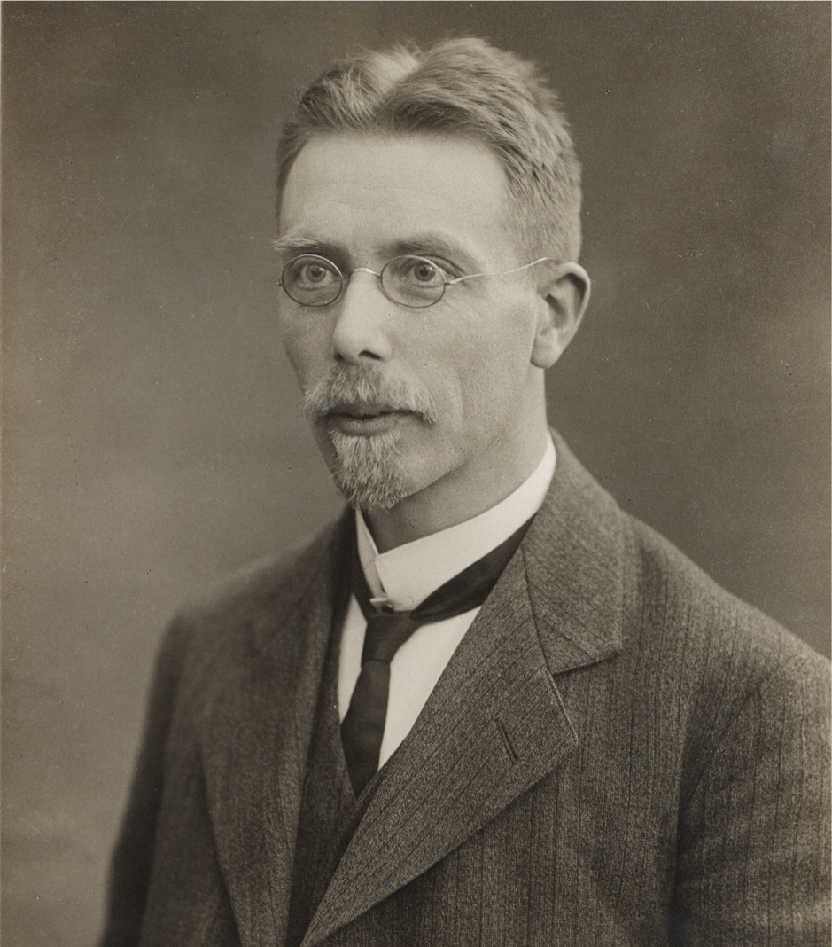

In 1924, August Krogh announced that profits from the sale of insulin would be used for the public good. This year, the Novo Nordisk Foundation celebrates its 100-year anniversary.

Novo Nordisk Annual Report 2023

Introducing Novo Nordisk

**Strategic Aspirations**

Risks

Management

Consolidated statements

Additional information 21



ESG Governance

We strive to conduct our activities in a financially, environmentally and socially responsible way. To achieve this objective and integrate sustainability considerations in Novo Nordisk’s strategy and core business, ESG is anchored and discussed in relevant governance bodies across the organisation.

Our ESG Governance model includes the Board of Directors’  
and Board Committees’ oversight and advice on ESG matters such as strategic direction and ambition level, as set by Executive Management. Their oversight also includes approval of our ESG reporting, variable remuneration components and more.

Operational decisions are anchored at the executive level in the Sustainable Business Execution Steering Group. It is composed  
of our Commercial Strategy & Corporate Affairs executive vice president and other senior sustainability leaders, including representatives of North America and International Operations. Supported by the underlying steering groups, the Sustainable Business Execution Steering Group provides guidance on implementation related to our social and environmental initiatives.

To ensure a well-rounded governance setup, we actively seek external input through our Sustainability Advisory Council. Comprised of experts from various fields, this independent body offers invaluable perspectives that challenge us to continuously improve our sustainability efforts. They provide constructive feedback on our current initiatives and help us explore innovative opportunities for the future. You can learn more about the council and its members at: www.novonordisk.com/sustainable-business/ esg-portal.html.



Audit

Committee

Oversees financial and ESG reporting.

Remuneration Committee

Determines executive remuneration, including based on sustainability targets.

Board of

Directors

Oversees strategic direction and advises on ambition level.

Executive Management

Decides on strategic direction, ambition level, targets, roadmaps and central funding, as well as financial and ESG reporting.

Sustainable Business

Execution Steering Group

Takes operational decisions to implement Executive Management’s decisions regarding core sustainable business priorities.

Social steering

groups

Sustainability Advisory Council

Provides non-binding recommendations on our Strategic Aspirations regarding purpose and sustainability. Composed of external experts.



Nomination

Committee

Assesses the competencies of the Board of Directors, including within ESG.

ESG Reporting Steering Group1

Provides guidance on ESG reporting, including implementation of new regulatory requirements.



1. The responsibility of the consolidated ESG statement resides in Finance.

Environmental

steering groups

Drive environmental initiatives, particularly with regards to circularity.

Drive social initiatives, related to global health equity, business ethics and others.

Novo Nordisk Annual Report 2023

Introducing Novo Nordisk **Strategic Aspirations** Risks Management Consolidated statements Additional information 22



EU Taxonomy

The EU Taxonomy is a European sustainability classification framework. It enables corporates to communicate to stakeholders which of their business activities have the potential to be considered sustainable (i.e. are Taxonomy- eligible) and report to which extent eligible activities fulfil EU requirements to be considered sustainable (i.e. are Taxonomy-aligned). For each relevant business activity, the company has to disclose how much of its Turnover, Operating Expenditures (OpEx) and Capital Expenditures (CapEx) can be considered eligible and aligned, respectively.

In 2023 we identified eligible economic activities based on the six published environmental objectives . Each of the economic activities was assessed on its percentage of Taxonomy-eligibility and, for those related to the environmental objectives of ‘Climate change mitigation’ and ‘Climate change adaptation’, also on their percentage of Taxonomy-alignment. As a result, we report 100%, 60% and 5% Taxonomy-eligible Turnover, CapEx and OpEx in 2023, respectively.

**Eligibility and alignment**

We followed a two-step process to arrive at our Taxonomy disclosures. Firstly, we screened the economic activities defined in the EU Taxonomy to identify those relevant under the Novo Nordisk business model. Based on our review and materiality considerations, we identified one new economic activity

to report on in 2023: ‘1.2 Manufacture of medicinal products’ under the environmental objective of ‘Pollution prevention and control’. Furthermore, like in 2022, we report Taxonomy-eligible CapEx for the economic activities ‘7.1 Construction of new buildings’ and ‘7.2 Renovation of existing buildings’ under the environmental objective ‘Climate change mitigation’.

Secondly, we evaluated whether we could classify any of our Taxonomy-eligible CapEx for economic activity 7.1 and 7.2 as Taxonomy-aligned. Although we have made progress in fulfilling the technical screening criteria, certain requirements in the design phase of the projects have not been fully met. Consequently, the existing projects do not meet the criteria for alignment in 2023. We strive for alignment of certain projects in 2024. Furthermore, we have started investigating the requirements, including CapEx plans, for reporting alignment of the activity ‘Manufacture of medicinal products’ with the aspiration of reporting alignment for part of the activities in 2024.

**Accounting policies**

Total Turnover consists of total revenue from sale of goods, as defined under IFRS. The Turnover KPI is defined as Taxonomy-eligible Turnover divided by total Turnover.

Total CapEx consists of additions to fixed assets (including financial lease) and intangible assets. Additions resulting from business combinations are also included. Goodwill is not included in CapEx as  
it is not defined as an intangible asset in accordance with IAS 38. The CapEx KPI is defined as Taxonomy-eligible CapEx divided by total CapEx.

Total OpEx consists of direct non-capitalised costs that relate to research and development, building renovation, short-term lease, maintenance and repair and any other direct expenditures relating to the day-to-day servicing of property, plant and equipment assets. OpEx excludes amortisations and impairments. The OpEx KPI is defined as Taxonomy- eligible OpEx divided by total OpEx.

None of our activities contribute to multiple objectives and hence do not require disaggregation of KPI’s. For the CapEx and OpEx allocations, we have identified the relevant purchases and measures as well as the primary related economic activity. Thereby, we ensure that no CapEx or OpEx is double counted. We are adjusting the R&D cost for amortisations to not double count these costs, as the amortisation would also have been part of CapEx in prior years.

**Contextual information about the KPIs**

We consider all Novo Nordisk’s revenue related to Manufacture of medicinal products. As Taxonomy-eligible, we only include CapEx directly associated with the manufacturing process or related to construction or renovation of buildings, hence intangible assets are excluded. This is the main reason for reported eligibility being less than 100%. Eligible CapEx mainly relates to the expansion of production capacity and consist of additions to property, plant and equipment, cf. note 3.2 to the Consolidated financial statements. Eligible OpEx mainly relates to research and development directly linked to manufacturing processes. The narrow EU Taxonomy OpEx definition is the main reason for a reported low eligibility.

**EU TAXONOMY ELIGIBILITY AND ALIGNMENT1**

**Turnover 2023**

(DKK million) (%)

176,954 100% N/A N/A 0 0% 0 0% N/A N/A 0 0% 0 0%

**CapEx**

**OpEx**

2022  
(DKK (DKK



2022

2022

(DKK million)

**2023**

(DKK million)

**2023**



**Environmental objective**

**Total Turnover, CapEx, OpEx**

**Taxonomy-non-eligible activities (B.)**

Climate change mitigation Pollution prevention and control

**Eligible not aligned (A.2. / A.1.+ A.2.)3**

**Eligible and aligned (A.1.)**

**Economic activity2**

7.1. Construction of new buildings  
7.2. Renovation of existing buildings 1.2. Manufacture of medicinal products

(DKK million)

(%)

(%)

(%)

million) (%) 23,348 100% 23,348 100%

0 0%

million) (%)



|  |  |
| --- | --- |
| **232,261** | **100%** |
| **0** | **0%** |
| 0 | 0% |
| 0 | 0% |
| 232,261 | 100% |
| **232,261** | **100%** |
| **0** | **0%** |



|  |  |
| --- | --- |
| **44,498** | **100%** |
| **17,996** | **40%** |
| 6,010 | 14% |
| 2,406 | 5% |
| 18,086 | 41% |
| **26,502** | **60%** |
| **0** | **0%** |



|  |  |
| --- | --- |
| **31,115** | **100%** |
| **29,646** | **95%** |
| 0 | 0% |
| 0 | 0% |
| 1,469 | 5% |
| **1,469** | **5%** |
| **0** | **0%** |

23,961 100%

20,788 87%

1,166 5% 2,007 8% N/A N/A 3,173 13%



0 0% N/A N/A 0 0% 00% 0 0%



1. A.1., A.2., A.1.+A.2. and B. refer to Annex V to the Commission Delegated Regulation (EU) 2023/2486 of 27 June 2023. Not disclosed data are all either 0 (zero) or not applicable. 2. None of the reported economic activities are Enabling or Transitional and we do not have any economic activities substantially contributing to ‘Climate Change Adaption’, ‘Water’, ‘Circular Economy’ or ‘Biodiversity’. 3. When allocating CapEx and OpEx to economic activities, we prioritise those that directly contribute to an environmental objective and for which specific technical screening criteria are set. Secondly, we link CapEx and OpEx associated with our primary economic activity, ‘1.2. Manufacture of medicinal products’.



Novo Nordisk Annual Report 2023 Introducing Novo Nordisk **Strategic Aspirations**

Risks Management Consolidated statements Additional information

23

**INNOVATION AND THERAPEUTIC FOCUS**

Broadening our pipeline for long-term innovation

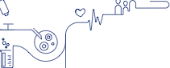

As the world grapples with the increasing impact of serious chronic diseases, Novo Nordisk is amplifying its research and development efforts to tackle these global health challenges head-on. Diseases like diabetes, obesity, cardiovascular disease and rare blood disorders pose significant threats to human health and society, demanding urgent action.

Guided by our purpose to drive change to defeat serious chronic diseases, we are broadening our pipeline of potential new treatments with an approach that is as comprehensive as it is innovative. Building on our 100-year heritage in protein and peptide engineering, we are harnessing the power of novel research technology platforms, leveraging cutting-edge data science tools and forging new strategic partnerships. This multi-faceted approach is enabling us to accelerate our research efforts and expand our footprint across multiple disease areas.

As our evolution from a diabetes-focused organisation to a broader cardiometabolic-focused company continues, our attention remains on areas with the highest unmet needs – and those where we are best positioned to compete. Strengthening our leadership position in both diabetes and obesity remains our top priority, while expanding our presence in cardiovascular disease and rare blood disorders is also a key focus.

We are stepping up our investment in these areas to build and maintain industry-leading pipelines, while at the same time seeking new opportunities to complement our in-house expertise with external innovation. Over the past year, this

emphasis on business development has resulted in the acquisition of biotechs including Inversago Pharma and Embark, two companies developing novel therapies with a potential application across a range of cardiometabolic diseases.

To further expand our capabilities, we have established a significant presence in the Greater Boston area, a world- renowned hub for innovation and cutting-edge science and technology. Through strategic partnerships, such as those  
with technology firm Valo Health and the Broad Institute of  
MIT and Harvard, we aim to accelerate our drug discovery and development efforts, expanding our use of human data, artificial intelligence and machine learning and tapping into our partners’ innovative genetics and genomics tools.

These extensive, wide-ranging efforts are already yielding positive results, including the initiation of clinical testing for cutting-edge cell therapy and siRNA (small interfering ribonucleic acid) treatments. Armed with an increasing array of novel research and development tools, we aim to move a greater number of projects into clinical testing at a faster pace, reducing the cost per project without compromising safety or quality.

**STRATEGIC ASPIRATIONS 2025**

1. Further raise the innovation-bar for diabetes treatment

2. Develop a leading portfolio of superior treatment solutions for obesity

3. Strengthen and progress the Rare Disease pipeline

4. Establish presence in Cardiovascular & Emerging Therapy Areas focusing on CVD, MASH and CKD

Novo Nordisk Annual Report 2023 Introducing Novo Nordisk **Strategic Aspirations** Risks Management Consolidated statements Additional information 24

Once-weekly insulin to set new standard in treatment

Our company was founded on the discovery and production of insulin, and we remain committed to pushing the envelope when it comes to insulin innovation. Our investigational once-weekly insulin icodec represents the latest major step forward in insulin care, potentially changing

the basal insulin experience for people living with diabetes.

*“If approved, insulin icodec will become the first once-weekly basal insulin option for adults with diabetes, reducing the number of weekly basal insulin injections from seven to just one.”*

Insulin icodec has been filed for regulatory approval in the US, EU and China, following phase 3a trials that demonstrated superior reductions in blood glucose levels and reduced incidence of severe hypoglycaemia compared to once-daily basal insulin degludec and insulin glargine U100 in insulin-naïve people with type 2 diabetes. If approved, insulin icodec will become the first once-weekly basal insulin option for adults with diabetes, reducing the number of weekly injections from seven to just one.

In the longer term, we are working on further improvements in insulin technology. This includes continuing to pursue the development of glucose-sensitive insulin, which only becomes active when the body’s glucose levels start to rise.

Taking diabetes treatment to the next level with CagriSema

Our determination to raise the bar in diabetes treatment is exemplified by CagriSema, our new investigational therapy for type 2 diabetes that has now entered large-scale phase 3 clinical development. This two-in-one medicine combines semaglutide with the amylin analogue cagrilintide, offering a novel mechanism to influence the gut-brain axis with the aim of improving glycaemic control in people living with type 2 diabetes. Cagrilintide works by reducing hunger and increasing satiety signals to the brain, providing an additive effect to semaglutide.

The decision to move into phase 3 development follows phase 2 results that showed a once-weekly subcutaneous injection of CagriSema reduced long-term blood glucose levels by 2.2 percentage points and outperformed its individual components in reducing body weight. CagriSema, which appears to have a safe and well-tolerated profile, previously commenced large-scale phase 3 trials in obesity in 2022, reflecting its broad potential across multiple therapy areas.

Rebecca Commanda lives with type 2 diabetes in Ontario, Canada.



Novo Nordisk Annual Report 2023

Introducing Novo Nordisk

**Strategic Aspirations** Risks Management Consolidated statements Additional information 25

Landmark trial underscores cardiovascular benefits of semaglutide

The success of our ground-breaking SELECT cardiovascular outcomes trial was a powerful endorsement of the efficacy and clinical importance of semaglutide as a treatment for people living with obesity and established cardiovascular disease (CVD).

The study was the largest ever completed by our company, involving more than 17,500 adults aged 45 and above with obesity and established CVD but no prior history of diabetes. The findings demonstrated a 20% reduction in major adverse cardiovascular events (MACE) for trial participants treated with semaglutide 2.4 mg compared to placebo – showing that semaglutide not only helps patients lose weight but can also improve cardiovascular outcomes.

The trial data showed this effect is consistent regardless of patient age, gender, ethnicity and starting BMI (body mass index), with risk reductions evident across heart attack, cardiovascular death and stroke. Importantly, the effect is seen soon after treatment initiation, suggesting that weight loss alone may not fully explain the benefits of semaglutide 2.4 mg in reducing the risk of MACE.

Every year almost 21 million people die from CVD, which is the leading cause of disability and death worldwide. While cardiovascular mortality has decreased over the past two

decades, obesity-related cardiovascular deaths have increased significantly. Obesity leads to cardiovascular morbidity and mortality and is associated with risk factors such as high blood pressure and inflammation.

*“It is the first time that an approved weight management medicine has been shown to reduce the risk of heart attacks, strokes and cardiovascular death.”*

It is the first time that an approved weight management medicine has been shown to reduce the risk of heart attacks, strokes and cardiovascular death. Novo Nordisk has filed for a label update of Wegovy® in the US and EU based on these findings, and a decision is expected in 2024. The US Food and Drug Administration has granted our submission a priority review.

Juan Pablo Villaseñor lives with obesity and cardiovascular disease in Ciudad de Mexico, Mexico.

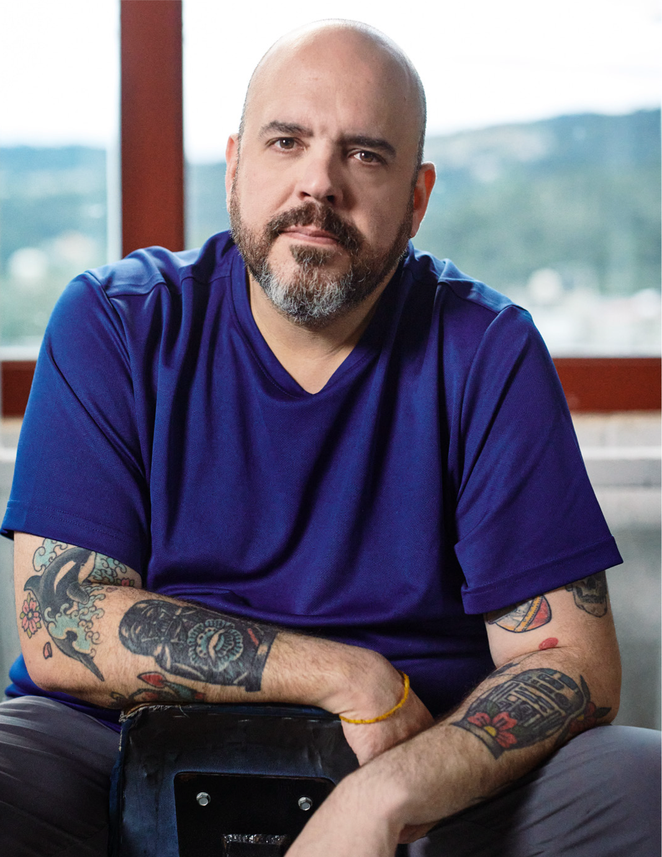

Novo Nordisk Annual Report 2023

Introducing Novo Nordisk

**Strategic Aspirations**

Risks

Management Consolidated statements Additional information 26



Next-generation treatments for rare blood disorders

Our Rare Disease unit – comprising treatments  
for rare blood and endocrine disorders – has a growing pipeline of exciting products, including two potential medicines for rare blood disorders with large unmet medical needs.

Mim8, our next-generation bispecific antibody for haemophilia A, is now in phase 3 development. Administered subcutaneously, it works by mimicking the function of the missing clotting factor VIII and is being tested as a treatment to prevent bleeds.

The experimental once-daily oral medicine etavopivat, also in phase 3 evaluation, offers potential benefits for people with sickle cell disease (SCD), a crippling and life-threatening condition caused by misshapen red blood cells. Acquired as part of the business development deal that brought US-based Forma Therapeutics in-house in 2022,

the investigational therapy is designed to modulate red blood cell health to reduce anaemia, pain, transfusions and strokes in people living with SCD.

**CARDIOVASCULAR & EMERGING THERAPY AREAS**

Expanding our footprint in cardiovascular disease



Cardiovascular disease (CVD) represents one  
of the greatest health challenges of our time. Affecting an estimated 620 million people across the globe, it takes a major toll on quality of life and is currently the leading cause of death worldwide.

At Novo Nordisk, we are determined to reduce the risk and burden of living with CVD, and over the past year we have taken significant steps  
to increase our footprint in this area of huge unmet need.

In October 2023, we strengthened our CVD pipeline with the acquisition of ocedurenone in a deal worth up to USD 1.3 billion. This mature clinical candidate targets uncontrolled hypertension – a leading risk factor for cardiovascular events, heart failure, chronic kidney disease (CKD) and premature death.

To date, ocedurenone has been investigated in nine clinical trials, and is currently in phase 3 development for the treatment of uncontrolled hypertension in people with CKD. We expect to initiate further phase 3 trials in the coming years as we seek to maximise its full potential.

Meanwhile, our first standalone CVD compound, ziltivekimab, is currently in phase 3 development for the treatment of atherosclerotic cardiovascular disease in people living with CKD. The ZEUS trial will include more than 6,000 patients in 38 countries, with completion expected in late-2025.

Masahiro Umehara (left) lives with haemophilia A in Tokyo, Japan. Pictured here with his son Masatsugu and his dog.

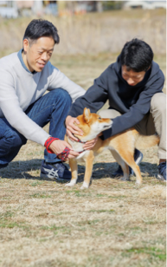

Novo Nordisk Annual Report 2023

Introducing Novo Nordisk

**Strategic Aspirations**

Risks Management Consolidated statements

Additional information

27

Pipeline overview

**DIABETES**

**Project**

Oral Semaglutide HD1  
NN9924

Icodec NN1436

IcoSema NN1535

CagriSema NN9388

GELA NN9506

Glucose-sensitive insulin  
NN1845

Pumpsulin NN1471

DNA Immunotherapy NN9041

OW GLP-1 GIP5 NN9541

OW Oral Semaglutide NN9904

**OBESITY**

**Project**

Oral Semaglutide NN9932

CagriSema NN9838

GELA NN9505

INV-202 NN9440

Amycretin NN9487

OW GLP-1 GIP NN9541

**RARE DISEASE**

**CARDIOVASCULAR & EMERGING THERAPY AREAS**



**Indication Description**

**Phase**

**Indication Description**

**Phase**

**Project**

Concizumab NN7415

Nedosiran NN7022

Mim8 NN7769

Etavopivat NN7535

Etavopivat NN7536

Etavopivat NN7537

NDec NN7533

**Indication Description**

**Phase**

**Project**

Ziltivekimab NN6018

Ziltivekimab NN6018

Ocedurenone NN6023

ATTR-CM NN6019

CM4HF NN9003

Anti-ANGPTL3 mAb  
NN6491

Semaglutide NN6535

Semaglutide NN9931

CagriSema NN9588

FGF21 NN9500

LXRa NN6582

MARC1 NN6581

VAP-1i NN6561

SC4PD NN9001

STAT3 NN4002

**Indication Description**

**Phase**



T2D2

T1D4 and T2D

A long-acting GLP-13 analogue, 25.0 and 50.0 mg, intended for once-daily oral treatment.

A long-acting basal insulin analogue intended for once-weekly subcutaneous treatment.

A combination of GLP-1 analogue semaglutide and insulin icodec intended for once-weekly subcutaneous treatment.

A combination of amylin analogue cagrilintide and GLP-1 analogue semaglutide intended for once-weekly subcutaneous treatment.

A collaboration with GE Healthcare, using ultrasound for once-monthly treatment.

A glucose-sensitive insulin analogue intended for once-daily subcutaneous treatment.

A novel insulin analogue ideal for use in closed loop pump systems.

A novel plasmid encoding pre- and pro-insulin intended for preservation of beta cell function.

A combination of GLP-1 and GIP co-agonist intended for once-weekly subcutaneous treatment.

An oral version of semaglutide intended for once-weekly treatment.

Obesity

Obesity

Obesity

Obesity

Obesity

Obesity

A long acting GLP-1 analogue intended for once-daily oral treatment.

A combination of amylin analogue cagrilintide and GLP-1 analogue semaglutide intended for once-weekly subcutaneous treatment.

A collaboration with GE Healthcare, using ultrasound for once-monthly treatment.

A CB-16 receptor inverse agonist intended for once-daily oral treatment.

A long-acting co-agonist of GLP-1 and amylin intended for once-weekly subcutaneous treatment or once-daily oral treatment.

A combination of GLP-1 and GIP co-agonist intended for once-weekly subcutaneous treatment.

Haemophilia A or B  
w/wo inhibitors

Primary hyperoxaluria type 1

Haemophilia A w/wo inhibitors

Sickle cell disease

Thalassemia

MDS7

Sickle cell disease

A monoclonal antibody against tissue factor pathway inhibitor (TFPI) intended for subcutaneous prophylaxis treatment.

An siRNA targeting lactate dehydrogenase A (LDHA) intended for once-monthly subcutaneous treatment.

A next generation FVIIIa mimetic bispecific antibody intended for subcutaneous prophylaxis of haemophilia A.

A second-generation small molecule PKR-activator intended for once-daily oral treatment.

A second-generation small molecule PKR-activator intended for once-daily oral treatment.

A second-generation small molecule PKR-activator intended for once-daily oral treatment.

An oral combination of decitabine and tetrahydrouridine. Project is developed in collaboration with EpiDestiny.

CKD8+ ASCVD9

HFpEF11

CVD12

CVD

CVD

CVD

Alzheimer’s

MASH13

MASH

MASH

MASH

MASH

MASH

Parkinson’s

Oncology

A once-monthly monoclonal antibody intended for inhibition of IL-610 activity.

A once-monthly monoclonal antibody intended for inhibition of IL-6 activity.

A small molecule, non-steroidal mineralocorticoid receptor antagonist (nsMRA) intended for oral treatment.

An anti-amyloid immunotherapy intended for intravenous treatment.

An investigational cell therapy intended for restoring heart function in people with chronic heart failure.

An ANGPTL3 neutralising sweeping antibody intended for once-monthly subcutaneous treatment.

A long-acting GLP-1 analogue intended for once-daily subcutaneous treatment.

A long-acting GLP-1 analogue intended for once-weekly subcutaneous treatment.

A combination of amylin analogue cagrilintide and GLP-1 analogue semaglutide intended for once-weekly subcutaneous treatment.

A long-acting FGF21 analogue intended for once-weekly subcutaneous treatment.

An siRNA targeting LXRa intended for once-monthly subcutaneous treatment.

An siRNA targeting MARC1 intended for once-monthly subcutaneous treatment.

A VAP-1 inhibitor intended for once-daily oral treatment.

A cryopreserved cell therapy intended for disease modifying treatment.

A GalXC-derived lipid conjugate one-time subcutaneous treatment.



T2D

T2D

T2D

T1D and

T1D

T1D

T2D

T2D

T2D



2022 2023

Phase 1

Phase 2

Phase 3

Submission

and/or approval



1. HD: High Dose. 2. T2D: Type 2 diabetes. 3. GLP-1: Glucagon-like peptide-1. 4. T1D: Type 1 diabetes. 5. GIP: Gastric inhibitory polypeptide. 6. CB-1: Cannabinoid receptor-1. 7. MDS: Myelodysplastic syndromes. 8. CKD: Chronic kidney disease. 9. ASCVD: Atherosclerotic cardiovascular disease. 10. IL-6: Interleukin-6. 11. HFpEF: Heart failure with preserved ejection fraction. 12. CVD: Cardiovascular disease. 13. MASH: Metabolic dysfunction-associated steatohepatitis.

Novo Nordisk Annual Report 2023 Introducing Novo Nordisk

**Strategic Aspirations**

Risks Management

Consolidated statements

Additional information 28

Research and development progress

**DIABETES**

Regulatory events

* Rybelsus® (oral semaglutide) was approved as first-line treatment option by the FDA.
* Results from Rybelsus® (oral semaglutide) formulation change and PIONEER PLUS were submitted to the EMA.
* Marketing authorisation application was submitted to the EMA, FDA, CDE and PMDA for approval of insulin icodec for treatment of both type 1 diabetes (T1D) and type 2 diabetes (T2D).
* Marketing authorisation application was submitted to the EMA for the approval of dasiglucagon for treatment of severe hypoglycaemia.

Clinical progress

* Phase 3b trial, PIONEER PLUS, investigating 25.0 and 50.0 mg oral semaglutide in patients with T2D was completed.
* Phase 3b trial, ASCEND PLUS, investigating oral semaglutide in patients with T2D and no history of prior myocardial infarction (MI) or stroke was initiated.
* Phase 3b kidney outcomes trial, FLOW, investigating subcutaneous once-weekly semaglutide 2.4 mg in people with T2D and chronic kidney disease (CKD) was stopped early based on interim analysis due to efficacy.
* Phase 3a programme, REIMAGINE, investigating once-weekly combination of semaglutide and cagrilintide in people with T2D was initiated.
* Phase 2 trial investigating the combination of semaglutide and GIP in people with diabetes was completed. The project was terminated.
* Phase 1 trial investigating the effects of the combination of semaglutide and SGLT2i inhibitor dapagliflozin in people with T2D was completed. The project was terminated.
* Phase 1 trial investigating the SOMA device for oral treatment was completed.
* Phase 1 trial investigating oral GLP-1/GIP co-agonist for treatment of T2D was completed. Novo Nordisk is planning to initiate a phase 2 trial with a subcutaneous formulation of the GLP-1/GIP co-agonist.

**OBESITY**

Regulatory events

• Wegovy® (semaglutide 2.4 mg) was approved for treatment of obesity in adolescents by the EMA.

• Wegovy® (semaglutide 2.4 mg) was approved as an adjunct to diet and exercise for the use of weight management in adults with obesity by the PMDA.

• Results from the phase 3b cardiovascular outcomes trial (CVOT) SELECT were submitted to the FDA and the EMA.

Clinical progress

• Phase 3b CVOT trial, SELECT, investigating subcutaneous once-weekly semaglutide 2.4 mg was completed.

• Phase 3a trial, STEP HFpEF, investigating subcutaneous once-weekly semaglutide 2.4 mg in people with HFpEF was completed.

• Phase 3a trial, OASIS 1, investigating oral semaglutide in people with obesity was completed.

• Phase 1/2 investigating NNC0165-1875 in combination with semaglutide in people with obesity was completed. The project was terminated.

• Novo Nordisk acquired Inversago Pharma, with lead assets INV-202 (a phase 2 ready asset for treatment of obesity) and INV-347 (a phase 1 ready asset for treatment of obesity).

**RARE DISEASE**

Regulatory events

• Marketing authorisation application was submitted to the EMA for the approval of concizumab for treatment of haemophilia A or B with inhibitors.

• A Complete Response Letter requesting further information was received from the FDA as a response to the concizumab marketing authorisation application.

• Alhemo® (concizumab) was approved for the treatment of haemophilia A or B with inhibitors by the PMDA.

• Sogroya® (somapacitan) was approved for treatment of growth hormone deficiency in children by the FDA, EMA and PMDA.

• RivflozaTM (nedosiran) was approved for the treatment of primary hyperoxaluria type 1 by the FDA.

Clinical progress

• Etavopivat transitioned from phase 2 to phase 3 trial in the ongoing seamless phase 2/3 HIBISCUS trial, investigating the safety and efficacy of etavopivat in adults and adolescents with sickle cell disease.

**CARDIOVASCULAR & EMERGING THERAPY AREAS**

Clinical progress

• Phase 3a trial, HERMES, investigating ziltivekimab in people with HfpEF was initiated.

• Novo Nordisk acquired ocedurenone, a phase 3 oral administrated small molecule, non-steroidal mineralocorticoid receptor antagonist for treatment of patients with uncontrolled hypertension and advanced CKD.

• Phase 1/2 trial investigating the ability of cell therapy HS-001 to restore heart function in people with advanced heart failure was initiated in collaboration with Heartseed.

• Phase 1 trial investigating ANGPTL3 mAb in people with cardiovascular disease was initiated.

• Phase 1 trial investigating the ability of cell therapy STEM-PD to restore dopamine nerve cells lost in the brain of people with Parkinson’s was initiated in collaboration with Lund University.

• Phase 1 trial investigating STAT3 in people with tumour- associated immune cells was initiated.

• Phase 1 trial investigating VAPi-1 in people with MASH was initiated.



Novo Nordisk Annual Report 2023 Introducing Novo Nordisk **Strategic Aspirations** Risks Management Consolidated statements Additional information 29

Patent status for products with marketing authorisation



The patent expiry dates for products marketed by Novo Nordisk1 are shown in the tables on the right. The dates provided are for expiry in the US, China, Japan and Europe of patents on the active ingredient, unless otherwise indicated, and include actual

and estimated extensions of patent term, when applicable. For several products, in addition to the active ingredient patent, Novo Nordisk holds other patents on manufacturing processes, formulations or uses that may be relevant for exclusivity beyond the expiration of the active ingredient patent. Furthermore, regulatory data protection and/or orphan exclusivity may apply.

**Product US China Japan Europe2 Product US China Japan Europe2 Product US China Japan Europe2**



Human insulin and Modern insulins3

Victoza®4

Tresiba®

Ryzodeg®

Xultophy®

Fiasp®

Ozempic®

Rybelsus®

Expired Expired

Expired Expired

2029 2024

2029 2024

2029 2024

20306 20306

2032 2026

2032 2026

Expired Expired

Expired Expired

2027 2028

20245 2028

20245 2028

20306 20306

2031 2031

2031 2031

Saxenda®

Wegovy®

Expired

2032

Expired

2026

Expired

2031

Expired

2031

Norditropin® (SimpleXx®)

Expired

Expired

No patent

2028

2032

Expired

Expired Expired

Expired Expired

No No patent patent

2027 2032

2029 2034

No Expired patent

Expired

Expired

No patent

2027

2034

Expired



NovoSeven

NovoEight®

Refixia® (REBINYN®)

Esperoct®

Vagifem® 10 mcg

®



1. This overview does not include products whose sales represent less than 0.5% of Novo Nordisk’s total sales. 2. Patent status varies from country to country. The figures in the table are based on Germany. 3. Modern insulins are NovoRapid® (NovoLog®), NovoMix® 30 (NovoLog® Mix 70/30), Levemir®. 4. We have granted and pending patents covering the Victoza® formulation. These patents generally expire in November 2024, except for the US where the formulation patent expires in February 2026. 5. Patent term extension until 2027 may apply. 6. Formulation patent; active ingredient patent has expired.



Novo Nordisk Annual Report 2023 Introducing Novo Nordisk **Strategic Aspirations** Risks Management Consolidated statements Additional information

30



**COMMERCIAL EXECUTION**

Stepping up to serve more patients  
in the face of unprecedented demand



Demand for Novo Nordisk medicines is soaring, driven by a global obesity epidemic and exceptional growth in the GLP-1 market. This has resulted in a record number of people being treated with our medicines, but also supply constraints. In response, we are significantly ramping up production capacity and have introduced clear prioritisation principles to ensure broad and equitable distribution of our products.

Our centenary year has been characterised by extraordinary growth, driven by surging global demand for our medicines. Faced with these unprecedented circumstances, we have reshaped our commercial execution strategy to best serve the record number of patients who rely on our medicines. By ensuring supply for patients in the greatest need while continuing to bring innovation to people living with serious chronic diseases all over the world, we aim to balance our financial and societal responsibilities.

Finding parity between the value we create and the values  
we aspire to has required some radical changes to normal commercial practices, along with a different mindset among sales staff. In many ways, we have rewritten the traditional rulebook for product launches by placing greater focus on the equitable distribution of limited supplies between different geographies and patient groups.

Our top priority is that patients currently on Novo Nordisk medicines continue to have uninterrupted access to an appropriate treatment option. We are also focusing on introducing new treatments to new markets in a more measured way, aligned

with our unwavering commitment to deliver innovation to as many patients across the globe as possible.

At the same time, we are investing heavily in new and upgraded production facilities in Denmark and other countries, increasing our capacity to meet current and future demand for our treatments and laying the foundation for sustainable long-term growth.

These investments include a record DKK 42 billion expansion of our flagship production site in Kalundborg, Denmark, which is already producing half of the world’s entire supply of insulin. Outside of Denmark, we are more than doubling the production footprint of our long-established facilities in Chartres, France, with investments totalling DKK 17 billion. Both projects will include state-of-the-art, multi-product facilities to accommodate current and future products and processes.

With construction under way on these major expansion projects, we strive to operate our facilities across the globe 24/7. In the past year, we have delivered more products to more patients than ever before, but such is the scale of demand that we expect periodic supply constraints to continue into 2024.

**STRATEGIC ASPIRATIONS 2025**

1. Strengthen diabetes leadership – aim at global value market share of more than 1/3

2. More than DKK 25 billion in Obesity sales by 2025

3. Secure a sustained growth outlook for Rare Disease

Novo Nordisk Annual Report 2023

Introducing Novo Nordisk

**Strategic Aspirations** Risks Management Consolidated statements Additional information 31

Strengthening diabetes leadership  
with strong GLP-1-based product growth

We have extended our leadership in diabetes care and increased our value market share by 1.9 percentage points  
to 33.8% in 2023, fuelled by strong uptake of the GLP-1-based products Ozempic® and Rybelsus® in both North America and International Operations.

Ozempic® is now the world’s biggest-selling diabetes medicine. Available as a once-weekly injection, it is contributing to a major shift in treatment for type 2 diabetes. At the same time, our oral GLP-1-based therapy, Rybelsus®, is gaining ground by offering patients with type 2 diabetes an intervention without injections. Demand for these two products has grown to unprecedented levels, helping to generate record sales growth despite supply constraints and a decline in demand for the first-generation GLP-1-based product Victoza®.

Although competition is increasing, Novo Nordisk remains the market leader in the GLP-1 market with a value share of 54.8%, broadly steady compared to 2022 where our value share stood at 54.9%.

The high demand for our GLP-1-based medicines is partly fuelled by a growing understanding of the importance of the class among healthcare professionals, patients and payers.

This includes a recognition that certain GLP-1-based therapies are not only highly effective options for controlling blood sugar levels, but may also offer significant benefits in terms of reducing weight and cardiovascular risks – positive effects now reflected in international treatment guidelines.

Despite declining sales of insulin in key markets, reflecting both pricing pressures and lower volumes in some geographies, Novo Nordisk’s insulin value market share remains little changed from 12 months earlier, at 43.9%, compared to 44.6% in 2022.

Across International Operations, insulin is still an important and growing segment, although insulin sales in China have been adversely impacted since the introduction of Volume Based Procurement in mid-2022. The US has also experienced a decline in overall volumes and a decrease in realised prices due to channel / payer mix and higher rebates.

Nevertheless, in a global diabetes market driven by high GLP-1 growth, we are uniquely positioned to maintain and strengthen our leadership in this sector and have already met our target of securing value market share of at least one-third by 2025.

**DIABETES VALUE MARKET SHARE** (%)

60 50 40 30 20

54.9% 43.8% 44.6%

**54.8% 43.9%**

**33.8%**

GLP-1 Insulin 50.4%

44.3%

29.3%

Total diabetes



52.7%



30.1%

31.9%



2020 Source: IQVIA MAT, Nov 2023.

2021 2022 **2023**

**DIABETES SALES** (DKK billion)  
Sales as reported Growth at CER

200 **29%**



160 120 80 40 0

14%



8%

13%



2020 2021

2022 **2023**

Novo Nordisk Annual Report 2023 Introducing Novo Nordisk **Strategic Aspirations** Risks Management Consolidated statements Additional information 32

Controlled launches for market-leading obesity therapy

Surging demand, limited supply and unprecedented global media attention on our ground-breaking obesity treatment, Wegovy®, have brought significant challenges – as well as exciting long-term opportunities.

Demand for Wegovy® is still growing strongly in the US, its first launch market, and we have taken proactive steps to conduct controlled and limited roll-outs in other major markets, with the goal of reaching the patients in greatest need of the therapy despite ongoing supply constraints.

*“Novo Nordisk is also reserving a share of Wegovy® supply in each new launch market for patients who cannot afford to pay for the product out of pocket.”*

In the UK, for example, Wegovy® is now available in specialist National Health Service weight management services for people who meet strict criteria, or else privately through a registered healthcare professional. UK physicians are being urged to prescribe responsibly and Novo Nordisk is also reserving a share of Wegovy® supply in each new launch market for patients who cannot afford to pay for the product out of pocket.

The success of Wegovy®, which builds on our experience with our first-generation GLP-1-based obesity product Saxenda®, means that Novo Nordisk has captured most of the growth and gained a clear leadership position in the obesity market. The sector remains extremely dynamic, with new players lining up to enter the space amid a growing appreciation that medicines tackling obesity have the potential to boost public health and cut long-term healthcare costs.

Globally, the number of people living with obesity has almost tripled since 1975 and is set to reach over 1.2 billion adults by 2030. The causes of obesity are complex and its consequences far-reaching because, so often, it puts people on a path to other diseases – not only diabetes, but also heart and liver diseases, cancers and many more.

Today, only one in 10 people living with obesity seek professional medical help – and only one in five of those receive treatment with a weight management medication. But attitudes are changing fast. The past two years have been characterised by a growing understanding among both the medical community and the public of the critical need to treat obesity, while an increasing number of people living with the disease are actively seeking support. We want to understand more about their journey and how we can continue to help them maintain their long-term progress towards better health.

**GLOBAL PREVALENCE OF OBESITY IN ADULTS** (millions) Obesity

2,000

1,600

1,200 1,007 813

800 400 0

1,532



1,246



Source: Obesity Atlas, 2023.

2020

2025 2030 2035

**OBESITY SALES** (DKK billion)  
Sales as reported Growth at CER

50 40 30 20 10

0

**154%**



84%



3%

55%



2020 2021

2022 **2023**

Novo Nordisk Annual Report 2023

Introducing Novo Nordisk

**Strategic Aspirations**

Risks

Management Consolidated statements Additional information 33

**PRODUCTION**

Expanding our production capacity to meet demand



Tackling the supply problems that prevent us from meeting the growing demand for our products is a top priority for Novo Nordisk. We know we must do more to ramp up capacity, and our colleagues in production are working around the clock to get additional supplies onto pharmacy shelves and into the hands of patients.

In the past year we have announced investments totalling more than DKK 75 billion into expanding capacity across our global network of production sites – including major expansions of our facilities in Kalundborg, Denmark, and Chartres, France, and the acquisition of a brownfield development and production site in Athlone, Ireland. There are, however, limits to how rapidly we can translate these investments into making more medicines that are ready for shipment. Pharmaceutical production must adhere to the highest possible standards, and we will never compromise on safety and quality for the sake of speed. In the meantime, we strive to operate our global manufacturing facilities 24/7 to maximise output from the current production base.

We are also thinking strategically about ways to remove bottlenecks in the supply chain. For example, we are seeking to alleviate pressure on device supplies by introducing our medicines in once-weekly rather than daily formulations, and we are exploring ways to reduce the reliance on single-use injection devices.

**CAPEX INVESTMENTS** (DKK billion)

30 24 18 12

6 0

**11%**

CapEx

CapEx to sales ratio



7%



5%

4%



2020 2021 2022 **2023**



Targeting sustainable growth in Rare Disease

Our Rare Disease unit had a challenging year, with sales decreasing by 15% as Norditropin®, our long-established treatment for growth disorders, was impacted by supply constraints due to a temporary reduction in manufacturing output. Sales of rare blood disorder products, meanwhile, were up 1% as a decline in NovoSeven® and NovoEight® sales was offset by growing demand for our newer haemophilia A and B therapies, Esperoct® and Refixia®.

Despite the challenges encountered this year, we remain confident that our rich pipeline in rare disease can bring growth back on track. The line-up of new therapies includes significant advances in both rare blood and endocrine disorders. Next-generation treatments – including Mim8 and Alhemo® in haemophilia – will add to growth in the medium term, while accelerated internal innovation and external business development will help us to build our presence in other rare disease areas of high unmet need, such as sickle cell disease.

In the rare endocrine space, our once-weekly treatment Sogroya® offers a new opportunity for people living with growth hormone deficiency by removing the burden of daily injections and offering demonstrated efficacy.

**RARE DISEASE SALES** (DKK billion) Sales as reported Growth at CER

25  
1% 4%



1%  
20 **-15%**



15 10 5 0

2020 2021

2022 **2023**



Novo Nordisk Annual Report 2023 Introducing Novo Nordisk **Strategic Aspirations**

Risks

Management

Consolidated statements Additional information 34

**FINANCIALS**

2023 performance and 2024 outlook

**Financial performance**

Sales increased by 31% measured in Danish kroner and by 36% at CER  
to DKK 232,261 million in 2023. Novo Nordisk’s 2023 sales and operating profit performance measured at CER were within the ranges provided in November 2023. The free cash flow, effective tax rate, capital expenditure as well as depreciation, amortisation and impairment losses were all in line with the guidance.

**Geographic sales development**

Sales in North America Operations increased by 50% measured in Danish kroner and by 54% at CER.

Sales in International Operations increased by 11% measured in Danish kroner and by 16% at CER. Sales in EMEA increased by 15% measured in Danish kroner and by 17% at CER. Sales in Region China increased by 3% measured in Danish kroner and by 11% at CER. Sales in Rest of World increased by 11% measured in Danish kroner and by 15% at CER.

**Sales development across therapeutic areas**

Sales in Diabetes care increased by 24% measured in Danish kroner and by 29% at CER. Sales of Obesity care products, Wegovy® and Saxenda®, increased by 147% measured in Danish kroner and by 154% at CER. Sales of Rare disease products decreased by 16% measured in Danish kroner and by 15% at CER.

In the following sections, unless otherwise noted, market data are based on moving annual total (MAT) from November 2022 and November 2023 provided by the independent data provider IQVIA.

**Diabetes care**

Sales in Diabetes care increased by 24% measured in Danish kroner and by 29% at CER to DKK 173,466 million driven by growth of GLP-1-based products. Novo Nordisk has improved the global diabetes value market share over the last 12 months to 33.8% from 31.9%.

The market share increase was driven by market share gains in both North America Operations and International Operations.

*GLP-1-based therapy for type 2 diabetes*

Sales of GLP-1-based products for type 2 diabetes (Rybelsus®, Ozempic® and Victoza®) increased by 48% measured in Danish kroner and by 52% at CER to DKK 123,132 million. The estimated global GLP-1 share of total diabetes prescriptions has increased to 6.0% compared with 4.5% 12 months ago. Novo Nordisk continues to be the global market leader in the GLP-1 segment with a 54.8% value market share.

Rybelsus® sales increased by 66% measured in Danish kroner and by 71% at CER to DKK 18,750 million. Sales growth was driven by North America Operations as well as EMEA and Rest of World.

Ozempic® sales increased by 60% measured in Danish kroner and by 66% at CER to DKK 95,718 million. Sales growth was driven by both North America Operations and International Operations. Sales growth

**FINANCIAL PERFORMANCE** (DKK billion) North America Operations net sales Growth at CER

International Operations net sales

300 250 200 150 100

50 0

**36%**



16%



7%

2020

14%



2021 2022

**2023**

**STRATEGIC ASPIRATIONS 2025**

1. Deliver solid sales and operating profit growth
2. Drive operational efficiencies across the value chain to enable investments in future growth assets
3. Deliver free cash flow to enable attractive capital allocation to shareholders

Novo Nordisk Annual Report 2023

Introducing Novo Nordisk **Strategic Aspirations** Risks Management Consolidated statements Additional information 35

has resulted in periodic supply constraints and related drug shortage notifications across geographies.

Victoza® sales decreased by 30% measured in Danish kroner and by 28% at CER to DKK 8,664 million as the GLP-1 market is moving towards once- weekly and tablet-based treatments. The sales decline was mainly driven by North America Operations.

*Insulin sales*

Sales of insulin decreased by 9% measured in Danish kroner and  
by 6% at CER to DKK 48,022 million. Sales decline at CER was driven by declining sales in the US and Region China.

**Obesity care**

Sales of Obesity care products, Wegovy® and Saxenda®, increased by 147% measured in Danish kroner and by 154% at CER to DKK 41,632 million. Sales growth was driven by both North America Operations and International Operations. Wegovy® has now been launched in the US, Denmark, Norway, Germany, the UK, Iceland, Switzerland and the United Arab Emirates. The volume growth of the global branded obesity market was 116% in 2023.

**Rare Disease**

Sales of Rare Disease products decreased by 16% measured in Danish kroner and by 15% at CER to DKK 17,163 million.

*Rare blood disorders*

Sales of Rare blood disorder products increased by 1% measured in Danish kroner and by 3% at CER to DKK 11,776 million driven by the extended half-life products in haemophilia B and A, partially countered by NovoSeven®.

*Rare endocrine disorders*

Sales of Rare endocrine disorder products decreased by 46% measured in Danish kroner and by 47% at CER to DKK 3,836 million reflecting  
a reduction in manufacturing output. Novo Nordisk is working on re-establishing supply of rare endocrine disorder products. Sogroya®  
has now been launched in five countries, and the initial feedback from patients and physicians is encouraging. Novo Nordisk has a value market share of 19.3% (MAT) in the global human growth disorder market.

**Development in costs and operating profit**

Rybelsus® as well as Obesity care market development activities.  
The increase in sales and distribution costs is impacted by adjustments to legal provisions.

Research and development costs increased by 35% measured in Danish kroner and by 37% at CER to DKK 32,443 million reflecting increased late-stage clinical trial activity and increased early research activities compared to 2022. The acquisition of Forma Therapeutics Inc. in 2022 and Inversago Pharma also increased R&D spending.

Administration costs increased by 9% measured in Danish kroner and by 11% at CER to DKK 4,855 million.

Other operating income and expenses (net) was DKK 119 million compared with DKK 1,034 million in 2022, mainly driven by lower income from partnerships related to Dicerna Pharmaceuticals Inc.

Operating profit increased by 37% measured in Danish kroner and by 44% at CER to DKK 102,574 million reflecting the sales growth.

**SALES BY THERAPEUTIC AREA** (DKK billion)

The cost of goods sold increased by 26% measured in Danish kroner  
and by 28% at CER to DKK 35,765 million, resulting in a gross margin  
of 84.6% measured in Danish kroner compared with 83.9% in 2022. Growth at CER The increase in gross margin reflects a positive product mix, driven by 125  
increased sales of GLP-1-based treatments. This is partially countered  
by costs related to ongoing capacity expansions, a negative currency  
impact and lower realised prices mainly in the US and Region China.

300 250 200 150 100

50 0

**36%**

**44%** 100% 80%

Diabetes care Obesity care Growth at CER

Rare Disease

16%

**OPERATING PROFIT AND MARGIN** (DKK billion)  
Operating profit (left axis) Operating profit margin (right axis)



7% 14%

2020 2021

50 25

7% 13%

2020 2021

60% 40% 20% 0%

100

Sales and distribution costs increased by 23% measured in Danish 75

kroner and by 26% at CER to DKK 56,743 million. The increase in costs is  
driven by both North America Operations and International Operations.  
In North America Operations, the cost increase is driven by the relaunch  
of Wegovy® and promotional activities for Ozempic®. In International Operations, the increase is mainly related to promotional activities for 0

15%



2022

**2023**

2022

**2023**

Novo Nordisk Annual Report 2023

Introducing Novo Nordisk **Strategic Aspirations** Risks

Management

Consolidated statements Additional information 36

**Financial items (net) and tax**

Financial items (net) showed a net gain of DKK 2,100 million compared with a net loss of DKK 5,747 million in 2022, reflecting gains on hedged currencies, primarily in US dollar.

In line with Novo Nordisk’s treasury policy, the most significant foreign exchange risks for Novo Nordisk have been hedged, primarily through foreign exchange forward contracts. The foreign exchange result was a gain of DKK 1,652 million compared with a net loss of DKK 4,651 million in 2022.

As per the end of December 2023, a positive market value of financial contracts of approximately DKK 1.6 billion has been deferred for recognition in 2024.

The effective tax rate was 20.1% in 2023 compared with an effective tax rate of 19.6% in 2022.

Net profit increased by 51% to DKK 83,683 million and diluted earnings per share increased by 52% to DKK 18.62.

**Cash flow and capital allocation**

Free cash flow realised in 2023 was DKK 68.3 billion compared with DKK 57.4 billion in 2022 supporting the strategic aspiration to deliver attractive capital allocation to shareholders. The cash conversion in 2023 is positively impacted by timing of payment of rebates in the US, including provisions related to the revised 340B distribution policy in the US. Income under the 340B Program has been partially recognised.

Capital expenditure for property, plant and equipment was DKK 25.8 billion compared with DKK 12.1 billion in 2022, primarily reflecting investments in additional capacity for active pharmaceutical ingredient (API) production and fill-finish capacity for both current and future injectable and oral products. Capital expenditures for intangible assets was DKK 13.1 billion in 2023 compared with DKK 2.6 billion in 2022 reflecting business development activities.

**CASH FLOW AND CAPITAL ALLOCATION** (DKK billion)

Operating profit growth is expected to be 21% to 29% at CER. Given the current exchange rates versus the Danish krone, growth reported in DKK is now expected to be around 2 percentage points lower than at CER. The expectation for operating profit growth primarily reflects the sales growth outlook and continued investments in future and current growth drivers within Research, Development and Commercial. Within R&D, investments are related to the continued expansion and progression of the early and late-stage pipeline. Commercial investments are mainly related to Obesity care market development activities as well as increased spend related to GLP-1 diabetes care.

Novo Nordisk now expects financial items (net) to amount to a gain of around DKK 1.3 billion, mainly reflecting gains associated with foreign exchange hedging contracts as well as interest gains from cash and marketable securities.

The effective tax rate for 2024 is expected to be in the range of 19-21%.

Capital expenditure is expected to be around DKK 45 billion in 2024 reflecting the expansion of the supply chain, including the previously communicated expansions of the manufacturing facilities in Kalundborg and Hillerød, Denmark, and Chartres, France. The investments in Kalundborg will create additional capacity across the entire global value chain from manufacturing of active pharmaceutical ingredients (API) to packaging, with the majority invested in API capacity. The API facility will be designed as a multi-product facility with flexibility to accommodate current and future processes. In Hillerød, the investments will create additional production capacity of API within Cardiovascular & Emerging Therapy Areas. The expansion of the production facilities in Chartres are related to additional aseptic production and finished production processes. In the coming years, the capital expenditure to sales ratio is still expected to be low double digit.

Depreciation, amortisation and impairment losses are expected to be around DKK 10 billion.

70 60 50 40 30 20 10

Dividend for prior year

Interim dividend

Share repurchases



0  
2021

1. Expectations for 2024.

**2024 outlook**

2022 **2023**

**2024E1**



Sales growth is expected to be 18% to 26% at CER. Given the current exchange rates versus the Danish krone, sales growth reported in DKK is expected to be around 1 percentage point lower than at CER. The guidance reflects expectations for sales growth in both North America Operations and International Operations, mainly driven by volume growth of GLP-1-based treatments for Obesity and Diabetes care. Intensifying competition and continued pricing pressure within Diabetes and Obesity Care are included in the guidance.

Following higher than expected volume growth in recent years, including GLP-1-based products such as Ozempic® and Wegovy®, combined with the expectation of continued volume growth and capacity limitations at some manufacturing sites, the outlook also reflects expected continued periodic supply constraints and related drug shortage notifications across a number of products and geographies. Novo Nordisk is investing in internal and external capacity to increase supply both short and long term. Novo Nordisk started gradually increasing the supply of the lower dose strengths of Wegovy® in the US in January 2024. A gradual roll-out of Wegovy® with capped volumes in International Operations is included in the guidance.

Novo Nordisk Annual Report 2023 Introducing Novo Nordisk **Strategic Aspirations** Risks Management Consolidated statements Additional information 37

The free cash flow is expected to be DKK 64-74 billion reflecting the sales growth, a favourable impact from rebates in the US countered by investments in capital expenditure.

All of the above expectations are based on assumptions that the global or regional macroeconomic and political environment will not significantly change business conditions for Novo Nordisk during 2024, including energy and supply chain disruptions, the potential implications from major healthcare reforms and legislative changes as well as outcome of legal cases including litigations related to the 340B Drug Pricing Program in the US, and that the currency exchange rates, especially the US dollar, will remain at the current level versus the Danish krone. Neither does the guidance include the financial implications of any new significant business development transactions and significant impairments of intangible assets during 2024.

Novo Nordisk has hedged expected net cash flows in a number of invoicing currencies and, all other things being equal, movements in key invoicing currencies will impact Novo Nordisk’s operating profit as outlined in note 4.4 on Financial risks.

**Forward-looking statements**

Novo Nordisk’s reports filed with or furnished to the US Securities and Exchange Commission (SEC), including this statutory Annual Report 2023 and Form 20-F, which are both expected to be filed with the SEC in January 2024 in continuation of the publication of this Annual Report 2023, and written information released, or oral statements made, to

the public in the future by or on behalf of Novo Nordisk, may contain forward-looking statements. Words such as ‘believe’, ‘expect’, ‘may’, ‘will’, ‘plan’, ‘strategy’, ‘prospect’, ‘foresee’, ‘estimate’, ‘project’, ‘anticipate’, ‘can’, ‘intend’, ‘target’ and other words and terms of similar meaning

in connection with any discussion of future operating or financial performance identify forward-looking statements. Examples of such forward-looking statements include, but are not limited to:

* statements of targets, plans, objectives or goals for future operations, including those related to Novo Nordisk’s products, product research, product development, product introductions and product approvals as well as cooperation in relation thereto,
* statements containing projections of or targets for revenues, costs, income (or loss), earnings per share, capital expenditures, dividends, capital structure, net financials and other financial measures,
* statements regarding future economic performance, future actions and outcome of contingencies, such as legal proceedings, and
* statements regarding the assumptions underlying or relating to such statements.

In this Annual Report 2023, examples of forward-looking statements can be found under the section related to our ‘Strategic Aspirations’ and elsewhere. These statements are based on current plans, estimates and

projections. By their very nature, forward-looking statements involve inherent risks and uncertainties, both general and specific. Novo Nordisk cautions that a number of important factors, including those described in this Annual Report 2023, could cause actual results to differ materially from those contemplated in any forward-looking statements.

Factors that may affect future results include, but are not limited to, global as well as local political and economic conditions, such as interest rate and currency exchange rate fluctuations, delay or failure of projects related to research and/or development, unplanned loss of patents, interruptions of supplies and production, including as a result of interruptions or delays affecting supply chains on which Novo Nordisk relies, shortages of supplies, including energy supplies, product recalls, unexpected contract breaches or terminations, government-mandated or market-driven price decreases for Novo Nordisk’s products, introduction of competing products, reliance on information technology including the risk of cybersecurity breaches, Novo Nordisk’s ability to successfully market current and new products, exposure to product liability and legal proceedings and investigations, changes in governmental laws and related interpretation thereof, including on reimbursement, intellectual property protection and regulatory controls on testing, approval, manufacturing and marketing, perceived or actual failure to adhere to ethical marketing practices, investments in and divestitures of domestic and foreign companies, unexpected growth in costs and expenses, strikes and other labour market disputes, failure to recruit and retain the right employees, failure to maintain a culture of compliance, epidemics, pandemics or other public health crises, effects of domestic or international crises, civil unrest, war or other conflict and factors related to the foregoing matters and other factors not specifically identified herein.

For an overview of some, but not all, of the risks that could adversely affect Novo Nordisk’s results or the accuracy of forward-looking statements in this Annual Report 2023, reference is made to the overview of risk factors in ‘Risk management’ of this Annual Report 2023.

**Expectations are as reported, if not otherwise stated**

**Sales growth**

at CER  
as reported

**Operating profit growth**

at CER  
as reported

Financial items (net)

Effective tax rate

Capital expenditure (PP&E)

Depreciation, amortisation and impairment losses

Free cash flow (excluding impact from business development)

**Expectations 31 January 2024**

|  |
| --- |
|  |
| 18% to 26% |
| Around 1 percentage point lower than at CER |
|  |
| 21% to 29% |
| Around 2 percentage points lower than at CER |
| Gain of around DKK 1.3 billion |
| 19% to 21% |
| Around DKK 45 billion |
| Around DKK 10 billion |
| DKK 64-74 billion |

Novo Nordisk Annual Report 2023

Introducing Novo Nordisk **Strategic Aspirations** Risks Management Consolidated statements Additional information 38

**OWNERSHIP STRUCTURE1**

Unless required by law, Novo Nordisk has no duty and undertakes  
no obligation to update or revise any forward-looking statement after the distribution of this Annual Report 2023, whether as a result of new information, future events, or otherwise.

**Shares and capital structure**

Through open and proactive communication, Novo Nordisk aims to provide the basis for fair and efficient pricing of our shares.

**Share capital and ownership**

Novo Nordisk’s share capital of DKK 451 million is divided into A and B share capital. The A and B shares are calculated in units of DKK 0.10, amounting to 4.51 billion shares. The A share capital, consisting of 1,075 million shares, has a nominal value of DKK 107,487,200 and the B share capital, consisting of 3,435 million shares, has a nominal value of DKK 343,512,800. Each A share of a nominal value of DKK 0.10 carries 100 votes and each B share of a nominal value of DKK 0.10 carries 10 votes. Novo Nordisk’s B shares are listed on Nasdaq Copenhagen and on the New York Stock Exchange (NYSE) as American Depository Receipts (ADRs).

The general meeting has authorised the Board of Directors to distribute extraordinary dividends, issue new shares in accordance with the Articles of Association and repurchase shares in accordance with authorizations granted.

The company’s A shares are not listed and are held by Novo Holdings A/S2, a Danish public limited liability company wholly owned by the Novo Nordisk Foundation. According to the Articles of Association of the Foundation, the A shares cannot be divested. Special rights attached to A shares include pre-emptive subscription rights in the event of an increase in the A share capital and pre-emptive purchase rights in the event of a sale of A shares, while B shares take priority for liquidation proceedings. A shares take priority for dividends below 0.5%, and B

shares take priority for dividends between 0.5 and 5%. However, in practice, A and B shares receive the same amount of dividend per share.

As of 31 December 2023, Novo Holdings A/S held a B share capital of a nominal value of DKK 19,018,300. Together with the A shares, Novo Holdings A/S’s total ownership amounted to a nominal value of  
DKK 126,505,500. Novo Holdings A/S ownership is reflected in the ‘Ownership structure’ chart.

There is no complete record of all shareholders; however, based on available sources of information, as of 31 December 2023 it is estimated that shares were geographically distributed as shown in the ‘Geographical split of shareholders’ chart. As of 31 December 2023, the free float of listed B shares was 92.96% (of which approximately 12.18% are listed as ADRs), excluding Novo Holdings A/S and Novo Nordisk’s holding of shares. As of 31 December 2023, Novo Holdings A/S and Novo Nordisk’s holding of B shares equaled 241,895,054 shares and had a nominal value of DKK 24,189,505. For details about the share capital, see note 4.2 to the consolidated financial statements.

**GEOGRAPHICAL SPLIT OF SHAREHOLDERS3** (% of share capital) Denmark



Novo Nordisk Foundation

Institutional and private investors



100%



Novo Holding A/S



77.1% 28.1%  
of votes of capital

22.9% 71.9%  
of votes of capital



North America UK  
Other

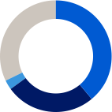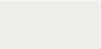

**A shares**

1,075m shares 23.8% of capital and 75.8% of votes

**B shares**

3,435m shares 76.2% of capital and 24.2% of votes

32

3  
26

39

Novo Nordisk A/S

1. Treasury shares are included; however, voting rights of treasury shares cannot be exercised. 2. Novo Holdings A/S’s registered address is Tuborg Havnevej 19, DK-2900 Hellerup, Denmark. 3. Split of shareholders is denoted according to the location of legal deposit-owners.

Novo Nordisk Annual Report 2023

Introducing Novo Nordisk **Strategic Aspirations** Risks Management Consolidated statements Additional information

39

**Capital structure**

Novo Nordisk’s Board of Directors and Executive Management consider that the current capital and share structure of Novo Nordisk serve the interests of the shareholders and the company well. Novo Nordisk’s capital structure strategy offers a balance between long-term shareholder value creation and competitive shareholder return in the short term.

In 2021, the capital structure was adjusted following Novo Nordisk’s Eurobond issuance with an aggregate principal amount of EUR 1.3 billion. In 2022, Novo Nordisk issued Eurobonds in the amount of EUR 1.5 billion. The total outstanding Eurobonds in 2023 amounted to EUR 2.8 billion.

**Dividend policy**

The company’s dividend policy applies a pharmaceutical industry benchmark to ensure a competitive payout ratio for dividend payments, which are complemented by share repurchase programmes. The final dividend for 2022 paid in March 2023 was equal to DKK 4.08 per A and  
B share of DKK 0.10 as well as for ADRs. The total dividend for 2022 was DKK 6.20 per A and B share of DKK 0.10, corresponding to a payout ratio of 50.3%. The 2022 pharma peer group average was 46.5%.

In August 2023, an interim dividend was paid equaling DKK 3.00 per  
A and B share of DKK 0.10 as well as for ADRs. For 2023, the Board of Directors will propose a final dividend of DKK 6.40 to be paid in March 2024, equivalent to a total dividend for 2023 of DKK 9.40 and a payout ratio of 50.19%. The company expects to distribute an interim dividend in August 2024. Further information regarding this interim dividend will be announced in connection with the financial report for the first six months of 2024. Dividends are paid from distributable reserves. Novo Nordisk does not pay a dividend on its holding of treasury shares.

**Share repurchase programme for 2023/2024**

During the twelve-month period beginning 1 February 2023, Novo Nordisk repurchased shares worth DKK 30 billion. The share repurchase programme has primarily been conducted in accordance with the safe harbour rules in the EU Market Abuse Regulation (MAR)4.

For the next 12 months, Novo Nordisk has decided to implement a new share repurchase programme. The expected total repurchase value of B shares, for the 12 months beginning 2024, amounts to a cash value of up to DKK 20 billion. The total programme may be reduced in size if significant business development opportunities arise during 2024. Novo Nordisk expects to conduct the majority of the new share repurchase programme according to the safe harbour rules in MAR. At the Annual General Meeting in March 2024, the Board of Directors will propose a further reduction in the company’s B share capital, corresponding to approximately 1.0% of the total share capital, by cancelling 45 million treasury shares.

**Share price development**

The Novo Nordisk price of the B share of a nominal value of DKK 0.20 was end of December 2022 DKK 938.00. Following the two-for-one stock split in September 2023, the B share price of a nominal value of DKK 0.10 was end of December 2023 DKK 698.10. The comparable share prices for B shares with a nominal value of DKK 0.10 were DKK 469.00 and DKK 698.10 at the end of 2022 and 2023 respectively, an increase of 48.8 %. The total market value of Novo Nordisk’s B shares, excluding treasury shares

and Novo Holdings A/S shares, was DKK 2,229,925,434,103, as of 29 December 2023.